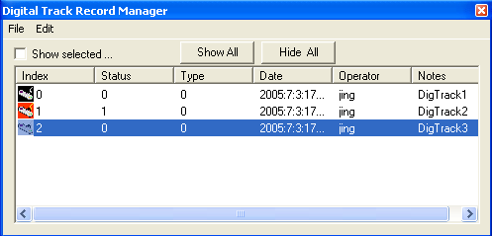
Digital Track Record Manager

The Digital Track Record Manager is designed for managing of all records. It allows user to add, delete, show and hide a specific records. Furthermore, it allows user to link the record to hardware for data acquisition.

Hints: In the list, red color indicates its item is currently linked to hardware for data acquisition. Black indicates it is currently hidden; while white indicates it is currently shown.

Show selected… It will hide all records and show the selected one only.

Show All: It will show all records.

Hide All: It will hide all records.

Menu File

Exit: it will exit the manage window.

Menu Edit
It has a few functions for manipulating the records.

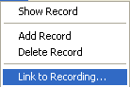
Show Record: it toggles the showing status of the selected item.

Add Record: it creates a new record and add to the list

Delete Record: it deletes the current record and removes it from the list

Link to Recording: it will link the current record to the data acquisition hardware.

