Dipole Manager

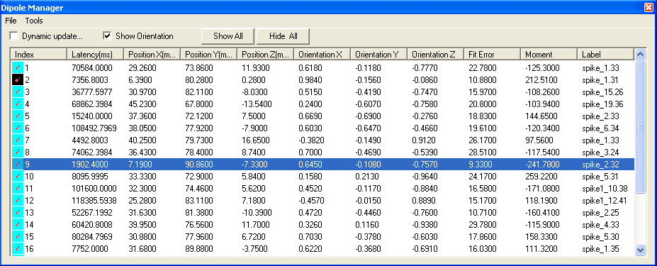
The Dipole Manager provides many functions for displaying dipoles. You can show or hide each single dipole or manipulate all dipoles at one click. If you select Show Current only, the display window will display the Selected dipole only.

Click the list title; such as Index, Latency (ms), etc, the manager will automatically arrange the dipoles.

Dynamic Update: If this is checked, only the selected dipole will be showed. Moving mouse or Up/Down arrow key will dynamically change the displayed dipole.

Show Orientation: If it is checked, the dipole orientation will be displayed. It likes a tail in the 3D or 2D view.

Show All: it shows all the dipoles.

Hide All: It hides all the dipoles.

File Menu

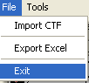
The File Menu has three functions: Import CTF, Export Excel and Exit.

Import CTF: it allows for importing CTF dipole file.

Export Excel: it provides a way for user to export the dipole data to Microsoft Excel file. This functionality is useful for further statistic analysis.

Exit: it will hide the Dipole Manager Wnd.

Tools Menu
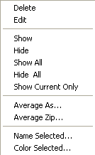
The Tools Menu has functions for editing and viewing the dipoles.

Delete: it deletes the current dipole in the list.

Edit: it shows the Dipole Editor Window for editing the current dipole in the list.

Show: it toggles the showing status (show or hide) of the current dipole.

Show All: it shows all the dipoles.

Hide All: it hide all the dipoles.

Show Current Only: it shows only the selected dipole.

Average As…: It produces an averaged dipole from the all selected dipoles.

Average Zip…: It produces an averaged dipole from the all selected dipoles and also deletes all original dipoles.

Name Selected. It gives a name to all selected dipoles.

Color Selected: It set a color to all selected dipoles.

