Dipole Coordinates
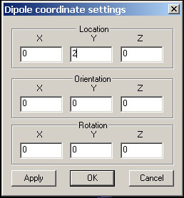
To co-register the anatomical imaging, such as MRI/CT, with functional imagines, such as MEG/EEG, we have to adjust the coordinates, so that the two imagines have the same coordinate. In the other words, the two images must overlap each other.

There are three parameters that can be adjusted. It includes location, orientation and rotation. The easiest way to adjust these parameters is to match the three or more fiduciary points. To do this, turn-on the fiduciary points (if they are hidden), match the three or more fiduciary points by changing the location and orientation.

Location: it contains the centre location of dipole coordinate.

Orientation: it contains the orientation of dipole coordinate.

Rotation: it rotates the dipole coordinate.

Apply: it applies all changes to all the dipoles.

