Dipole Editor
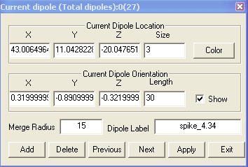
The Dipole Editor window provides interfaces for adding, deleting and editing dipoles. You can also change the color and the size of the dipole with a few types and clicks.

Current Dipole Location: it shows the location of the currently selected dipoles. When you select a new dipole in the dipole manager, it will update the editor dynamically.

Current Dipole Orientation: it shows the orientation of the currently selected dipoles. When you select a new dipole in the dipole manager, it will update the editor dynamically.

Merge Radius: it is used for integration of MRI and MEG. The radius indicates the region of each dipole will be presented.

Dipole Label: it is used for edit the label of each dipole. For changing a group of dipoles, please use the “Name Selected…” menu.

Add: it adds a new dipole.

Delete: it deletes a new dipole.

Previous: it shifts the current dipole to the previous one.

Next: it shifts the current dipole to the next one.

Apply: it applies all settings to the current dipole.

Exit: it hides the current window.

