Magnetic Source Locator

By Jing Xiang, M.D, Ph.D

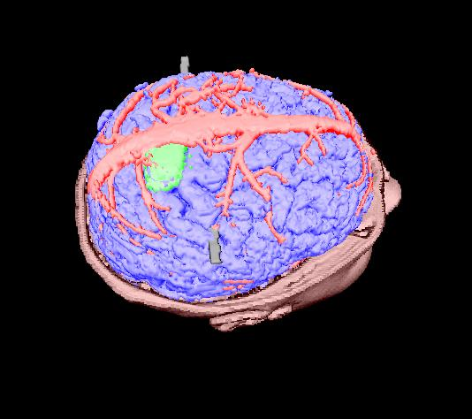

Introduction

Magnetic Source Locator (MSL) is a powerful combination of 3D rendering, functional mapping and dynamic digitalization. It uniquely integrates anatomical volume data, functional mapping information and dynamic digitalization points into a single environment. It provides capabilities for automatic registration, semi-automatic segmentation, and generation of 3D surface models, 3D visualization, and quantitative analysis of various medical imaging. One goal of developing MSL is to build a environment for virtual anatomical navigation and imaging-guided surgery. Another goal is to provide a portable image processing software package designed especially for researchers working on diagnostic imaging.

Installing and Updating MSL

Before you install MSL, make sure your computer meets the following minimum system requirements.

Hardware Requirements
CPU: 600 MHz or higher processor (1000 MHz recommended);
- Memory: 128 MB or higher (512 MB recommended);
- Hard disk: 300 MB or more;
- Video Card: 3D accelerated video card recommended;
- CD-ROM or DVD-ROM or CD-ReWritable drive;
- Microsoft Mouse or compatible pointing device;

Software Requirements:
Prior to installing MSL, you need the following software installed on your system.
- Microsoft Windows 98/MI/2000/XP (Windows 2000 recommended).
- Imaging processing software – if you plan to capture 2D images.
- FTP software – if you plan to transfer file between PC to various workstations.

Install MSL
- Insert a MSL CD into your CD-ROM drive
- Wait for a few seconds, the installation software will automatically run.
- Click Install.
- Click Next if you accept the copyright agreement.
Fill the User Name, Company and Serial Number fields correctly,othwise installation may stop there and can't go ahead
- Click the Finish, then you should be able to see a short-cut
on the desktop

Update MSL
To upate MSL, just insert the update CT into the CD drive, it should automatically update all components.
- If it does not run automatically, do the following things.
- Insert a MSL CD into your CD-ROM drive
- Find the fold in you C drives during you installing MSL
- Copy the MSL update files into MSL fold, when the computer ask if you would like to overwite the exist files, please select yes.

Uninstalling MSL
You may need to uninstall MSL. To do so, follow these steps:
- On the Start menu, choose Settings, then Control Panel. The Control Panel appears.
- Double-click Add/Remove Programs. The Add/Remove Programs Properties dialog box appears
- Select MSL, click Add/Remove
- The Perform Unistall window appears
- Click Next untill the Finish button appears.

