MSL Environment

Starting MSL
You can start the application in any of these ways:
1, Double-click the application icon in the Program group;
2, Double-click the short cut icon on the desktop;
When the software running, the MSL environment will appear. After you use the MSL, it remembers what windows you had open when you last used the application and opens those windows the next time you run the product.
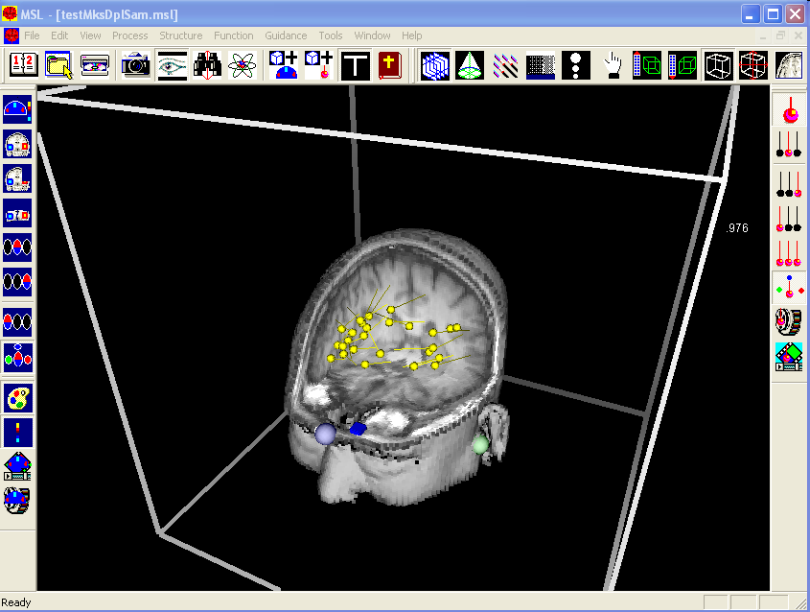

Exiting MSL
To exit from MSL, choose Exit from the File menu. You are prompted if you have unsaved changes.

Using the Main Window
The following illustration shows the components of MSL main window.
You can access functions in MSL using any of these methods:
- Selecting a menu option
- Clicking a toolbar button
- Using a keyboard shortcut
The procedures in this guide instruct you to perform a function either using eh menu command or the toolbar button. As you become familiar with the options, use the method you are most comfortable with.

Using the Toolbars
Several toolbars provide quick access to commonly used commands and functions. They are:
- The Main Toolbar
- The Segment Toolbar
- The Dipole Toolbar
- The SAM Toolbar
- The Animation Toolbar
You can relocate a toolbar by dragging it to a new location anywhere in the window. You can hide a toolbar using the appropriate View menu command.

Hint: Many of the toolbar buttons are “grayed out” if no file is open. If a toolbar button is grayed out, the function is not currently available.

