Edit Menu
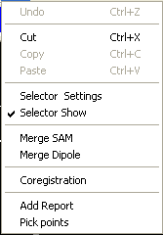

There are several menus are available in Edit pop menu. If the menu is not enabled, it indicates the function is not available. You can cut, isolate, mark and explore the volume data.

Undo:
It is used in correction of mistakes.

Cut:
Using this function to cut the selected area.

Copy:
Copying selection to another 3D object.

Paste:
Paste the cut or copied 3D object into current active 3D view.

Selector Settings
3D Selector Settings will let you to select, cut and explore the 3D object in 3D environment. With the 3D Selector Settings, you can get what you would.

There are many functions are available to edit the 3D volume data. The most frequent used functions were designed by using “Buttons”, a simple click will let you finish a task.

Selected Dimension: With the 3D Selector Settings, you can adjust the size or the dimension of the 3D selector (See in the following figures) by dragging the three sliders: the Width, the Height and the Depth.

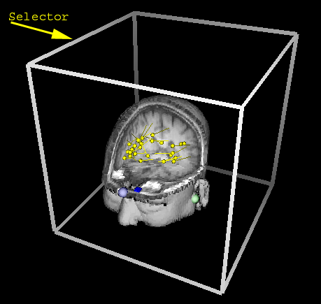
- Width: The size of the selector in X direction (left to right). In 3D environment, it is easy to get confused with direction, if you do, please try to press ESC key, this will return all images into original direction.

- Height: The length of the selector in Y direction (bottom to top). In 3D environment, it is eay to get confused with direction, if you do, please try to press ESC key, this will return all images into origial direction.

- Depth: The length of the selector in Z direction (front to back). In 3D environment, it is eay to get confused with direction, if you do, please try to press ESC key, this will return all images into origial direction.

Hint: The three fiduciary points are always useful in 3D environment, red color indicates right ear, green color indicates left ear, and blue indicates nasion.

Selected Central Location: With the 3D Selector Settings, you can move the 3D selector by dragging the three sliders.

- X: The center of the selector in X direction (left to right). The unit is voxel; therefore, it is not the absolute distance. When the point is on the left side of the center of the whole volume data, the volume should be minus. For example, if the size is 100, the center should be 50, and x value of a point on the left side of the center will be minus. Please move the slider and watch the changes of the number.

- Y: The center of the selector in Y direction (bottom to top). The unit is voxel; therefore, it is not the absolute distance. Please move the slider and watch the changes of the number.

- Z: The center of the selector in Z direction (front to back). The unit is voxel; therefore, it is not the absolute distance. Please move the slider and watch the changes of the number.

- Faster: If the data are huge, check this to run faster. It is not used in most of cases.

- Mark: This will mark the selected area with Mark1.

- Explore: This function will explore the selected area by showing the gray scale in cut surface. It is very useful for users they are already familiar with MRI or CT films.

- Scope: This function will show the selected area by showing the marked components in cut surface. It is very useful for users they are already marked some specific components and would like to see it in certain cut level.
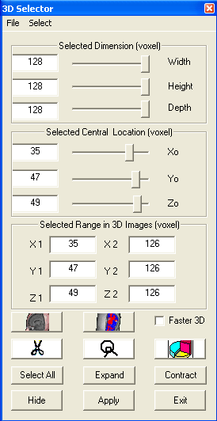
- Hide: Clicking the button will hide or show the select frame, which indicates the range and location.

- Cut: Clicking the button will cut off the selected area.

- Crop: Clicking the button will crop or isolate or extract the selected area. It is exactly the opposite of the Cut function.

- Apply: If the changes you made do not take effects, try to click the apply button.

- Exit: When you finished your work, click Exit and return to main window.

Select Menu: There are several functions are available to 3D Selector Settings.

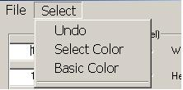
- Undo: If you did something wrong, clicking this button will bring back what you lost.

- Select Color: clicking this menu can change the color of the selected area.

- Basic Color: clicking this menu can change the basic color of the whole volume data. A color dialog will appear and you can select any color you like.

Selector Show

This menu allows users to hide or show the 3D Selector (see the above 3D Selector).

Merge SAM
To merge the SAM image(s) with structural image(s), select this menu.

Merge Dipole
To merge the dipole(s) with structural image(s), select this menu.

Coregistration
This function allows for user to do multi-modal integration by registering the fiduciary points.

Add Report
To add the current image to the report, use this function.

Pick Points
This function allows user to pick a point in 3D image(s) and show the corresponding 2D image(s) if any linked 2D window(s) are opening.

Picking Voxel:

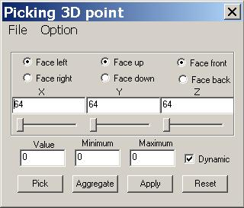
3D Picker will let you to pick certain voxel; in addition, you can view 3 Plane in 3D environment.

- Face Left and Face Right: 3D Picker can cut the value data in two ways, if you select the face left, then 3D Picker will cut the volume data on the left side.

- Face Up and Face Down: 3D Picker can cut the value data in two ways, if you select the face up, then 3D Picker will cut the volume data on the up side.

- Face Front and Face Back: 3D Picker can cut the value data in two ways, if you select the face front, then 3D Picker will cut the volume data on the front side.

- X, Y and Z: the corner used in cutting the faces.

- Value: the value indicates voxel value of a point of the X,Y and Z located.

- Minimum and Maximum: the values indicate the minimum and maximum voxel value of all points picked by the 3D Picker

- Dynamics: When this is checked, then any action, such as moving sliders, will take effect immediately. It allows users to see the changes dynamically.
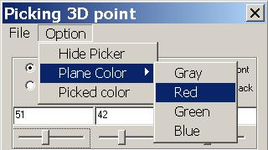
- Pick: This will pick up the point located by the X, Y and Z values. Actually, it marks the point for aggregating.

- Aggregate: This button will dilate the picked points and aggregate them. It is useful in segmentation or visualization of tumor.

- Apply: Validating all changes immediately.

- Reset: cleaning all picked points.

- Option Menu: This menu provides several options for picking voxel or viewing the 3 planes.

- Hide Picker: This function will hide the Picker, which is a point, like a small ball.

- Plane Color: Check the color menu will change the color of the 3 planes. It was designed for 3-plane view.

- Picked color: It can change the color of the picker.

Co-Registration:
This function will check the co-ordinates of volume data, dipoles, SAM files and digitalized data. If the data are not co-registrated, then do the co-registration.

Hint: 3 fiduciary points are always useful in co-registration. If the 3 fiduciary points (all data should have, otherwise, set them before you go ahead) are not match, then you need manually do it.

Hide 3D Selector
The 3D selector you use in 3D Selector Settings may still on the screen and you would like to hide it. Then, just toggle it.

