Files

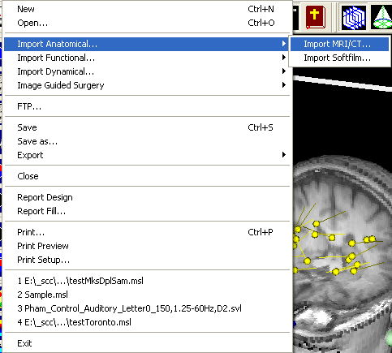

MSL can read many structural and functional files. You build a MSL file by importing anatomical, functional and dynamic digital files. This chapter describes how to import, open, export and save files.

Importing Anatomical…
According to our investigation, almost of all diagnostic images are DICOM compatible or will be DICOM compatible. Therefore, CT/MRI/Ultrasound can be imported into MSL. To import DICOM files into the MSL:

- Start MSL program;
- Select File menu;
- Select Import Anatomical-> import MRI/CT
- An import dialog window will appear (Figure 2);
- If you know which system you are using, select the corresponding DICOM filemene and select all 3D scanning slices (click the first file, press shift key+the last file). If you do not know what kind of DICOM files you have, try to use DICOM3.0/General/….

Hint: To do 3D reconstruction on MRI/CT, the data should be scanned with 3D protocols. If you do not sure, try to use Import 2D to 3D

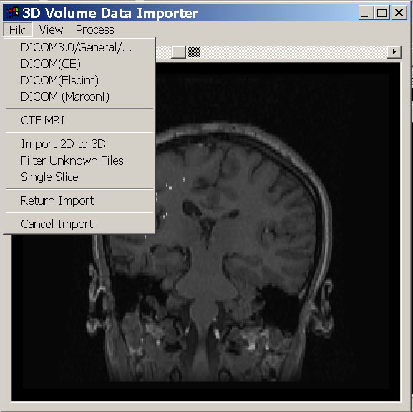
- The displayed images can be viewed in several ways.
- Select View menu ->View Control, a view setting dialog will appear (Figure 3)
- To adjust view pointer, view range, light and contrast, move the corresponding bars. The Focus Scale indicates the discrimination of gray scale in the images. Generally speaking, the bigger the number is, the easier separating two kinds of tissues is. Sometime, it is a matter of taste, so try different focus scale and use your favorite one.

Hint: The Raw indicates the data are viewed in “raw scale”, it should be same as the one from the system (like CT/MRI raw data). You can adjust the view point, view range, brightness and contrast bar to get a better imaging.

- The imported images can be primarily processed. The most important thing in this step is to decide the dimensional scale. If you are using a office PC, let’s say, 256 MB memory with 1.0G Hz CPU, we would like to recommend 128 scale.
- Select Process->Dimensional Scale, then a scale dialog will appear and you can select which one you perfer.
- The gray scale of the images can also processed. By default, the program will change it to 256 scale before it return to 3D environment.
- Select Process->Gray Scale, then a scale dialog will appear and you can select which one you perfer

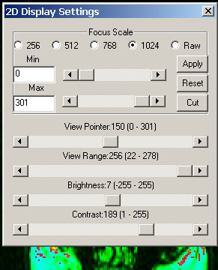

Import Functional…
To import one or more functional images, select File Menu, and highlight Import Functional…. If you would like to import SAM files, do the following steps.
- Select SAM files menu, an open file dialog will appear, select one or more files (Select more than one files, please press left mouse button and press Ctrl or Shift key, depends on how you would like to pick up the files).
- Once files have been selected, press OK button. The software will check each file for various purposes, such as fiduciary points, imagine types, etc.

To import one or more dipole files, select File menu, and highlight Import Functional. Select Dipole Menu to import dipoles.

Import Dynamical…
To import dynamical data, like Polhemus digitize log file, select File menu, and highlight the Import Dynamical…
- Select Polhemus log file.
- Click the desired file and Press OK button.

Add …
To add digital data into current 3D data, select File menu, and highlight the Add Menu->Digital Data

Open or New
You can open documents in many different locations from the Open dialog box in MSL, however, the files you are going to open must be MSL files, not raw data from other system. You can open a document on your computer hard disk or on a network drive that you have a connection to. You can also open a document on a network, even if you don't have a connection to a network server, as long as your network supports UNC addresses.
If your company has an intranet, or if you have access to the Internet (for example, if you have a modem and an Internet account through an Internet service provider, or if you are in a corporation and have access through the network), you can open a document located at an HTTP site on the World Wide Web or at an FTP site. If your company has an intranet, you can open documents there. For documents located on your computer hard disk or on a network drive that you have write access to, you can open a document as a copy if you want to create and work on a copy of the document instead of the original. And regardless of where the document is located, you can open a document as read-only if you want to make sure you don't change the original document.

You need to make a new file in order to import aforementioned raw files. Simplely click the NewMenu, a new file will be make.

Save or Save as a new file
To save the worked data, select File menu and select Save. Or, click the Save button on the toolbar.
To save an opened file as a new file, select the File menu and select the Save As. Then, a new file saving dialog will appear. You can type a new name and click Save button to save the new file. The program will automatically add extension to the file if you forgot typing it.

Export
To export 3D imaging to 2D image, select the File menu and select Export, click the Bitmap file menu, a save file dialog will popup. You can type a name and save the current 3D imaging to 2D-image file.

