Guidance Menu
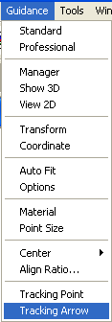

Standard Acquisition
The Standard Acquisition is used for acquiring data in single monitor. Clicking this menu will invoke a data acquisition window, which allows user to acquisition data.

Professional Acquisition

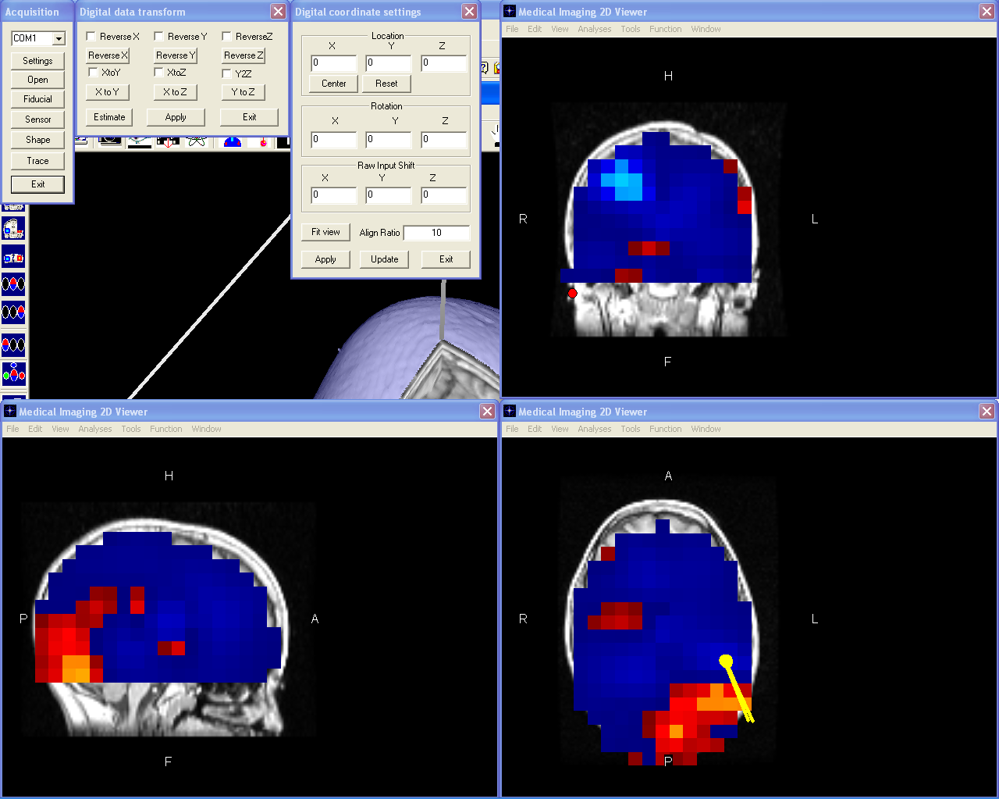

The Professional Acquisition is suitable for two monitors. In addition to the data acquisition window, it shows 2D images and 3D images simultaneously. Furthermore, professional acquisition shows all related windows for data transform and display.

Manager
This menu will show the digital track manager window. It allows users to add, delete, show or hide the records. Further more, it allows user to link the record to data acquisition hardware.

Show 3D
This menu will toggle the display of the digitalized data. When the digitalized data are displayed, this menu is checked.

View 2D
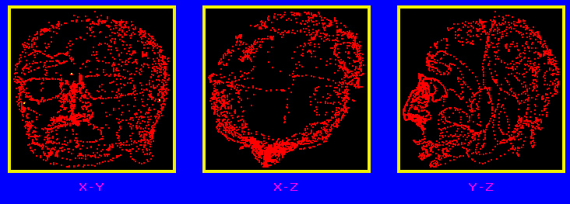
If you would like to see the 2D dimensional image of the digital data, you click this menus and a 2D window will popup.

Transform
This menu invokes a window and let you change the co-ordinate of the digitalized system.
You can reverse and exchange X, Y and Z coordinates by clicking the corresponding buttons. Basically, it changes the orientation of the digitalized data.

Coordinate
The coordinate function is used for changing the location and orientation of the digitalized data. It is different from the transform that changes the orientation of axes.

Auto fit
The Autofit function will fit the digitalized data in the view.

Options
The options provide a user interface for changing the display. You can display the digitalized data as point, cube or sphere by selecting the radio buttons.

Material
You can change the 3D dimensional display material with this menu. Click this menu will invoke a material window.

Point Size
The point size is useful for display the digital data with point. Changing the size of point may change the appearance of the 3D view of the digital data.

Locate…
This function allows user to adjust the center location of the 3D coordinates of digital data by pressing the left mouse button and move (up-down is Y axis; left-right is X axis). Rotating the middle button will change the depth (Z value in the 3D coordinates) of the 3D display.

Rotate…
This function allows user to adjust the rotation of the 3D coordinates of digital data by pressing the left mouse button and move. Rotating the middle button will cause rotation according to X-axis.

Align…
This function allows user to adjust the align ration of the digital data by pressing the left mouse button and move. This is commonly used to change the unit between the software and the hardware, or to correct nose.

Tracking Point…
This function allows user to adjust size of the tracking point. Please note the tracking point is the recently digitalized point.

Tracking Arrow…
This function allows user to adjust size and expected extending of the tracking Arrow. Tracking Arrow needs two points, the arrow is pointing from the last one to the previous one.

