Help Menu
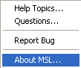

Help Topics
It will show the help information. If it is installed.

Questions
It shows the frequently asked questions (FAQ) if it is installed.

Report Bug
To report any bugs, us this function.

About MSL
It provides some information about this program.

