Menu Structure

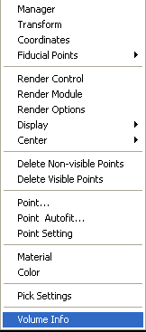

Manager
This menu invokes a window to manage all volume data items. You can hide (or display), delete and edit all volume data in the Manager Window.

Structural Item Manager: The Structure Manager displays all available structure data. Here are the titles for the structural item list.

Transform
The Transform function evokes a dialog and allows transforming the three-dimensional coordinates of the active volume item (Please refer to Structural Manager for more details of active item).

Coordinates
This menu invokes a window to the location and orientation of the volume data. Generally speaking, this function is used only by super user for specific purpose.

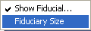
Fiduciary Points

This popup menu has two functions. One is to show or hide the fiduciary points for the structural images; and another is to change the size of the fiducial points.

Show Fiducial…: it shows or hides the fiducial points.

Fiduciary Size…: it changes the edit mode of the software and allows user to adjust the size of the fiducial points.

Render Control
The View Control is to set the visible range of the gray scale of the volume data and define which tissue(s) should be displayed.

Use the Minimum and Maximum slide bars to control the visible range. The areas, actually the points, which are outside of the visible range, are not displayed, so they are hidden. This is very useful for showing the interesting tissues, like bone or vessel.
The Brightness and Contras are more commonly used in 2D display or segmentation. They do not make big difference in 3D rendering in most of cases.

Render Module
The Render Module is very useful when users are familiar with 3D rendering. It allows users to render the structural images in optimized way or rendering some specific features.

The invoked Dialog allows users to select the rendering modules, which includes Fast (default), Safe, Smoggy and Raw.

Further more, the render module also allows users to select how the images will be merged. The option includes merging with dipole, SAM and none. The Merge SAM let you merge the SAM imaging into MRI imaging. The final imaging will be the combination of the both.

The Color Enhance will allow users to enhance the color of the functional images such as the SAM color in merged imaging.

Render Options
The Render Option is very useful when user has marked a specific structural item (tissue). Please note that the render options indicate the “component” within each item in the Manager list. Therefore, a structural data (anatomical data set) has several tissues (items in the Structural Manager), each tissue has several rendering components. This “tree” and “list” construction can be used in displaying very complicated human body with functional and anatomical information.

The render components include MK1, MK2 and both (MKs). To display any possible single component or combination, the Render Options provides all with build-in radio check for you to select.

Users can check the range of gray scale and use the full range in the 3D rendering. Further more, users can change the color of the Marks.

Display
The display menu provides functions for controlling the display.
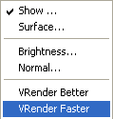
Show…: The Show menu will show or hide the structural image(s).

Surface…: The Surface menu will toggle the rendering type from Volume Rendering to Surface rendering.

Brightness… it will change the edit mode of the program so that user can change the brightness and contrast of the gray scale display by pressing-left mouse button and moving it. Being careful, if the display does not has gray scale image, it will appear nothing happening.

Normal: The Normal menu is designed for advanced or power users to change the OpenGL normal values. It can change the 3D rendering characteristics.

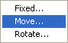
Center

The Center menu provides functions to change the location and orientation of the center of the coordinate for structural data.

Fixed…: it fixes the coordinate system. User can not change it.

Move…: it allows user to move the center of the coordinate system using mouse.

Rotate…: it allows user to rotate the coordinate system of the structural data using mouse.

Delete Non-visible Points
This program can control the visible points, users can deleted the non-visible points with this function.

Delete Visible Points
This is a function designed for special usage. Generally speaking, visible points are useful. However, users may need to see some hidden information, such as subtle blood in the cerebral spinal fluid. This is the function to use: first cut all normally visible points, and then shift the non-visible points to visible points. Some subtle abnormalities can be visible now.

Point…
This function is designed for adjusting the size of volume rendering points using mouse.

Point Autofit
This function is designed for volume rendering. It changes the size of the rendering points according to the volume.

Point Setting
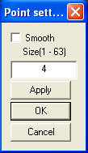
This function is designed for volume rendering. Users can manually change the size and smoothness of the rendering points.

Material
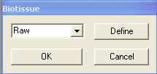
The material refers to the basic material used in the 3D rendering of the 3D object. It includes some build-in defines.

Users can define a new type by pressing the Define button.
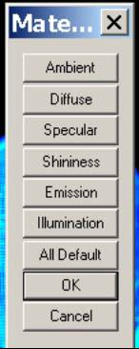

Color
The color refers to the basic color used in the 3D rendering of the 3D object. Users can change the color by picking a new one with the following dialog.
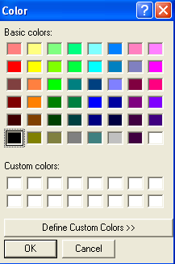

Pick Settings
This function allows user to setup the Pick function.
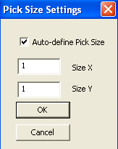
The default values is auto-define Pick Size. Unchecking it will allow user to define the value. Generally speaking, the X and Y values should be larger than 1.

Volume Info
This function will show the basic information about the 3D images including dimension and space in three-directions.

