Tools Menu

DICOM Inspector
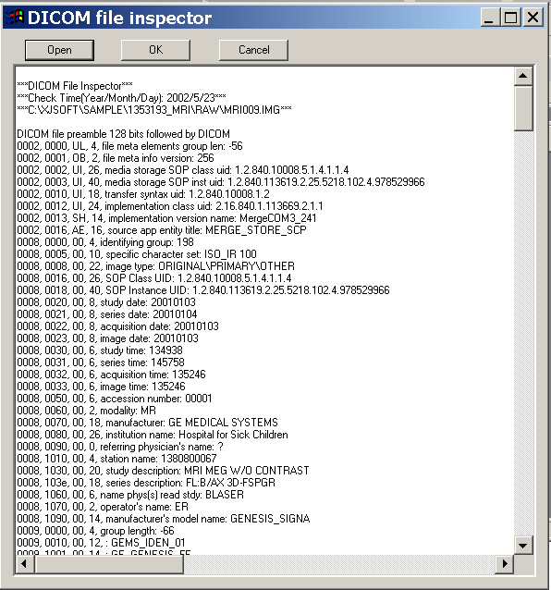
Almost all medical images are DICOM compatible. DICOM is one kind of medical imaging format. DICOM means the digital imaging and communication in Medicine. To be able to access and understand all medical imaging, this function is provided. If you have a new medical imaging, try use DICOM inspector and find out the secretory of the file.

Screen Shot
When you prepared a nice 3D picture, you probably would like to capture the picture and save it as a 2D image. The screen shot is provided for such kind of purpose. You can capture the screen either directly past to another program or save it as a file.
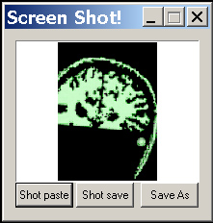
The Shot paste button let you capture screen and then paste it to other program. And the Shot save let you capture the screen and then save as as file. The Save As function save the current already captured picture as a file.

3D Implementation
This function inspects the 3D-rendering engine used in the current computer. It is very useful for find out the most suitable computer hardware and configuration. Please note that fast computer (CPU and hard disk) does not mean fast 3D rendering, further more, expensive video card and monitor does not mean nice 3D picture. We would like to use this function to find out the exact implementation of 3D rendering.

3D Colour
This function just reports the current colours used by the 3D-rendering engine.

