View Menu

Show toolbar
The Show Toolbar menu shown in Figure 3-1 provides menu options for showing or hiding the toolbars including Main Toolbar, Segment Toolbar, Dipole Toolbar and SAM Toolbar. When a menu is checked, the corresponding toolbar is displayed on the main window. The toolbar can be dragged to anywhere you like on the screen. If you would like to hide a toolbar, just uncheck the corresponding menu.

- Main Toolbar: This menu will toggle (show or hide) the Main Toolbar. The buttons on this toolbar are basic functions, such as save file, open file, and capture the screen etc. They are the most commonly used functions.
- Segment Toolbar: This menu will toggle (show or hide) the Segment Toolbar. The buttons on the Segment Toolbar will let you select segmental methods by popping up a dialog.
- Dipole Toolbar: This menu will toggle (show or hide) the Dipole Toolbar. This toolbar will let you to view the selected dipole or all dipoles. It is very handy to analyze or view dipoles overlapped on 3D MRI, particularly, when you have a lot of dipoles.
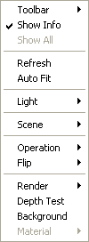
- SAM Toolbar: This menu will toggle (show or hide) the SAM Toolbar. The SAM Toolbar was designed for checking SAM peaks. If you have more then one SAM files, we recommend you to use the SAM manager and the SAM settings to view multiple SAM images.

Toolbar
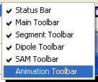
The Toolbar menu includes all toolbars used in this program. The major toolbars as followings:

Status Bar
The Status Bar will toggle (show or hide) the status at the bottom of the main window. It is strongly recommended to check this menu because the on-line help of all buttons and menus are displayed here.

Main Toolbar
The Main Toolbar will toggle (show or hide) the major toolbar at the top of the main window. It is strongly recommended to check this menu because the functions involve all images such as save, open and rotation, etc.

Segment Toolbar
The Segment Toolbar will toggle (show or hide) the major toolbar at the top of the main window. All functions related to structural information are in this toolbar.

Dipole Toolbar
The Dipole Toolbar will toggle (show or hide) the Dipole toolbar on the right of the main window. All functions related to dipoles are in this toolbar.

SAM Toolbar
The SAM Toolbar will toggle (show or hide) the SAM toolbar on the left of the main window. All functions related to SAM are in this toolbar.

Animation Toolbar
The Animation Toolbar will toggle (show or hide) the Animation Toolbar on the left of the main window. All functions related to Animation Toolbar are in this toolbar.

Auto Fit
The Auto Fit menu will check the window size and the viewing subject, and figure out the suitable view distance in the 3D dimensional environment. It is very useful when you are lost during zooming or when you opened a huge or tiny 3D object and what you see is a totally a messy. Try the Auto Fit, it will help you a lot.

Light
The Light Menu will lead you to a new pop up menu which was designed for setting the light of 3D images. In the current version, you can have at least six lights. You can also set each light and highlight the corresponding light.

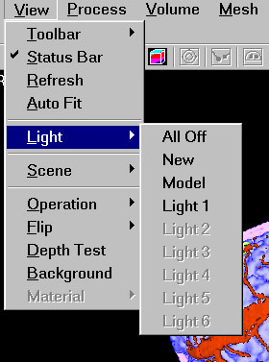
All Off: In some case, you may like to turn off all lights, then you can check the All Off menu, it will turn off all light. You can view the 3D image without light, this is useful to identify the material of 3D subject, particularly, you would like to compare multiple objects.

New: This menu will make a new light. You need to check this before you can set more one light.

Model: When select this menu, a setting dialog will pop up. You can adjust the global ambient light intensity. It means the whole viewing field will be changed. The colors, red, blue and green, are used in producing light, this will effect the appearance of any 3D object in the view.

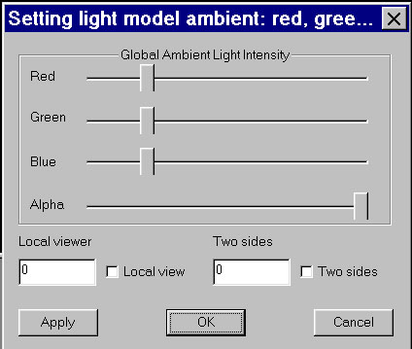
The Alpha value is used internally for 3D experts, it will change the transparency. The local viewer and two sides view for professional 3D workers, some video cards may not support those functionality.
Apply will send the new settings to the program and render it. This dialog is system modal, you must press either OK or Cancel button.
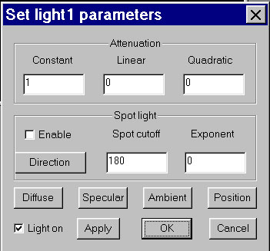

Light 1- 6: Select any of the light menus will pop up a new dialog, which will let you to set the characteristics of the corresponding light.

The attenuation is how the light becomes weaker as with the distance from the light. You can set the constant, linear and quadratic value and apply them. The spot light, if enabled, will change the light as a spot light, you can set the spot cutoff and exponent. Spot light has direction, you can set the direction by click the direction button.

You can set a specific light by click the Diffuse, specular and ambient buttons. The position of a light can be set by click the Position button. Unchecking the Light on selector will turn of the light.

Scene

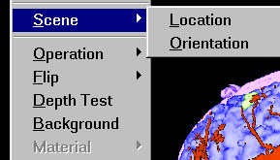
The Scene menu will pop up two new menus, the Location and the Orientation. The location and orientation are effecting the entire scene or view, including all objects on the window.

- Location: Select the Location menu will pop up a new dialog and let set the location of entire view or world translation. In the world translation dialog, X indicates left to right, Y indicates inferior to superior, Z indicates frontal to back.
Hint: If you rotated your 3D object, you are probably lost your direction. Therefore, you may get what you don’t want. To help you find out the right direction, press the Esc key, this will return the entire view to original location and then try change the X, Y and Z value.

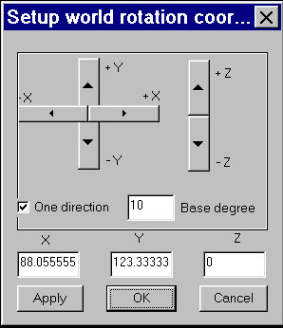

- Orientation: Orientation is the direction of the whole scene orientated. Select this menu will pop up a new dialog and let you set the orientation of the 3D viewing.

In the world rotation dialog, X indicates left to right, Y indicates inferior to superior, Z indicates frontal to back. You can rotate the 3D view in any direction. Base degree is how much the 3D has to rotate when you click X, Y or Z bar once. One direction will let you rotate the 3D view just in one direction, in case you have rotate the 3D object in various ways and you actually not sure the angle is you desired. Clicking the Apply button will take the changes into the current 3D rendering.

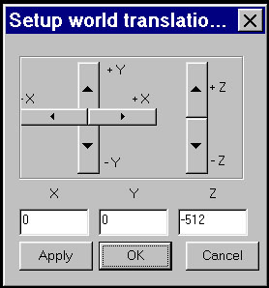

Operation
The Operation Menu provides special operations on the display window. It change the window, more specifically, the MSL viewer, into an operational modal, when you move the mouse, the view will be changing continuously. Please note the cursor for the different operational modal.

- Visibility: The display window will change to visibility modal. The rules as followings:
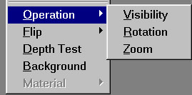
- Moving mouse from left to right increases the view range. For example, view range 120 – 255 is probably showing bone (it is depending on the scan window), changing the view range from 120 – 255 to 1 – 256 will display almost all brain tissue.
- Moving mouse from bottom to up will increase viewpoint, or the view window. For example, when changing the viewpoint from 20 to 200, the displaying tissue may change from brain gray matter to white vessel or bone.
- Moving mouse from left up to right bottom several times will increase the viewer range and display all visible tissue. On the other hand, moving mouse from right bottom to left up corner will decrease view range, it may just show bone or even nothing.

- Rotation: When selecting the rotation menu, the MSL view will into rotation modal. In rotation modal, moving mouse (press left mouse button and move) will rotate the 3D objects. To identify the direction, please turn on the fiduciary points. In current version MSL, red point indicates right ear, green indicates left ear and blue indicates nasion.

Hint: If you do not like to use mouse, you can also use keyboard: pressing arrow keys or page keys will rotate the 3D objects.

- Zoom: the Zoom menu will let you zoom the view by moving the 3D object far away or close to the viewer. Pressing the left mouse button and moving the mouse upward will zoom in, pressing the left mouse and moving the mouse down will zoom out the view.

Hint: Double click will zoom in, Double click with Ctrl key pressing will zoom out.

Flip
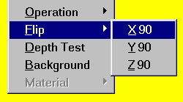
The Flip Menu can flip all the 3D objects in the view immediately.

- X90: flip the 3D objects around X-axial (left-right).
- Y90: flip the 3D objects around Y-axial (up-down).
- Z90: flip the 3D objects around Z-axial (front-back).

Depth Test
This function is provided for professional users to adjust the 3D rendering depth. When 3D images render in the computer memory, the depth (from front to back) will be tested.
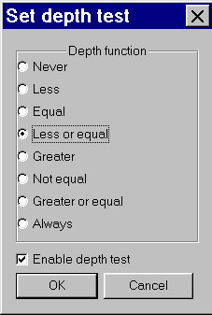
It was strongly recommended that you always enable depth test. If you are not familiar with the detail mechanism of 3D rendering, please do not change the default settings. You can read more information about depth test on any OpenGL and Direct3D programming books.

Background
The background menu invoke a color dialog, you can chose any color for your 3D view background. It is a minor function, just play with it.

