Window Menu

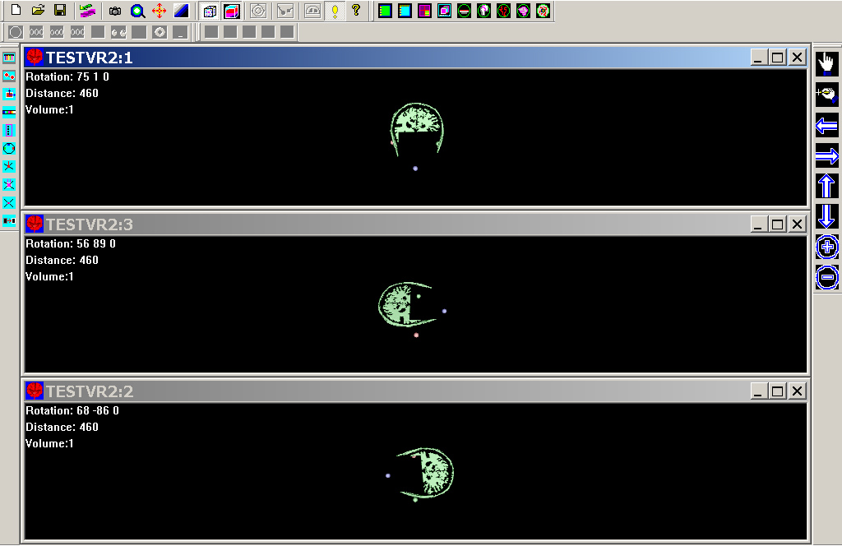
Windows

There are several features in window menu. First of all, you can make a new window to display the same 3D data, and adjust the display. It is very tricky, because the window system will try to update and synchronize them. If you would like to show same data set with different view, don’t update them all (no clicking on the window you don’t would like to update).

All functionality, like cascade, tile and Arrange Icons are native Microsoft Window (x)’s functionality.

Window Manager
This function is designed for managing the 2D image windows.

