Function Menu

(SAM)
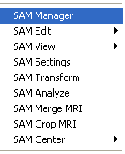

SAM Manager
The SAM Manager provides an easy to understand interface for manipulating SAM images. At the left up corner of the SAM Manager window, there is a small color icon indicates the color type of the SAM imaging. If you would like to apply one action to all some images, select the check box. A change will be applied to all SAM images. Several functions are available by pressing the right mouse button on the Manager Window.

SAM Edit
SAM Editor provides a window for editing SAM imaging, such as group cut and crop.
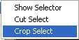

The SAM Selector provides an interface for editing SAM images. The main functions are cutting and cropping the selected area.

Show Selector: it shows the 3D selection window, which has a few build-in functions.

Cut Select: it will cut the selected area.

Crop Select: it will crop the selected area.

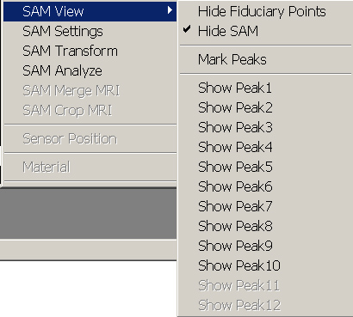
SAM View

The SAM View provides a lot of functionalities for manipulate SAM viewing. One of the main features in SAM images is the Peak. The Peak indicates a local activation or suppression. It may be the region of interest (ROI) for a particular study.

Show or Hide Fiduciary Points: this will toggle the display of SAM fiduciary points.

Show or Hide SAM: this function will toggle the display or SAM image itself.

Mark Peaks: This menu invokes a window for marking SAM peaks.

In the Mark Peaks window, the Absolute Threshold (T) indicates the SAM value (such as T or Z) at which can be marked. The Minimum Separation indicates how far of the two SAM peaks. You can mark either Activation (s) or Suppression or both. If you checked the Mark all, then the marking action will be applied to all SAM files.
The Mark Peaks button marks the peaks.

Show Peak1 – Peak12: These manus will show its corresponding peak. The number indicates the ID number in all peak lists. If there is a MRI or other volume data, it will cut the volume data and show SAM peaks.

SAM Settings
SAM Settings menu invokes a SAM settings window, which allows you to set various parameters for display SAM, images.

SAM Transform
This function can transfer all SAM images. It can change SAM direction and axis.
You can change the co-ordinate by clicking the above buttons; it is very straightforward.

SAM Analysis
SAM information can be statistically analyzed with this function.

The SAM analysis window will calculate all SAM point, voxel value (it can be T, Z or any SAM value). The SAM information is divided as two groups: activation and suppression. Each group has four parameters: total points, total voxel, average voxel and total volume.
Please note that the total points are affected by the step (or space in X, Y and Z direction).

Hint: you can input the active or suppressive number in the Activation and Suppression text boxes, and press the Update button. Then the SAM data will be re-analyzed and display to you the new results.

SAM Merge MRI
This function is to show SAM imaging on the MRI, it integrated into MRI, therefore, the SAM color is display on MRI. If the current SAM imaging is merged into current MRI, then the menu will be selected. Otherwise, it keeps unselected.

SAM Crop MRI
Sometime, it is very meaningful to show the SAM imaging with MRI constrains. This function is for this purpose. It just displays visible SAM with corresponding MRI volume data. Anywhere without SAM or MRI will be hidden.

SAM Centre
This menu will allow user to change the centre location and rotation of SAM image by mouse. It change the edit mode of the program.

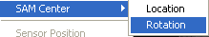
Location: it allows user to change the location of the SAM image. The cursor will indicate the mode.

Rotation: it allows user to change the rotation of the SAM image. The cursor will indicate the mode.

