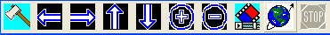
Animation Toolbar

The animation toolbar provides the functions for users to cut the 3D object in three directions; furthermore, users can rotate the 3D objects.

It changes the viewer as cut-edge mode. Users can use the following arrows to cut the brain in various directions.

It cut the 3D object from the left side.

It cut the 3D object from the right side.

It cut the 3D object from the top.

It cut the 3D object from the bottom.

It cut the 3D object from the front.

It cut the 3D object from the back.

It cut and animates the 3D object.

It rotates the 3D object.

It stop the animation.

