Surface Erase 2D
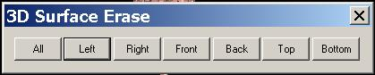
The Surface Erase will let you cut the surface of any volume data. It is very useful when you would like to check the tissue from outside, like skin, to the deeper area, like brain material. You can cut layer with 1 to entire volume data according to your need.

- All: cut the surface in all directions.

- Left: cut the surface from left.

- Right: cut the surface from right.

- Front: cut the surface from front.

- Back: cut the surface from back.

- Top: cut the surface from top.

- Bottom: cut the surface from bottom.

