Surface Mark 3D

Mark Layer
Mark Layer will let you mark the surface of any volume data. It is very useful when you would like to check the tissue from outside, like skin, to the deeper area, like brain material. You can mark layer with 1 to entire volume data according to your purposes.

- Left: Mark left side only.

- Right: Mark right side only.

- Front: Mark front only.

- Back: Mark back only.
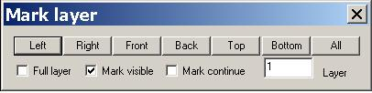
- Top: Mark top only.

- Bottom: Mark bottom only.

- All: Mark all directions.

- Full layer: If this check box is checked, the mark action will mark all layers.

- Mark visible: If this check box is checked, only the visible points will be marked.

Hint: In volume rendering, there are more points than what you see, some points are hidden because we would like you to see the internal structure. You can use the View Control ( in volume section) to adjust the threshold of hiding.

- Mark continue: This check box will let the mark action continue even if a point has been marked by other actions. It is used by professional user.

Layer: It indicates how deeper the mark action will go from the outside, such as skin. This is an important parameter in analysis the surface.

