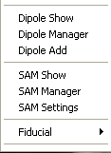
Standard Analysis Window – Menu Function

The function menu allows users to control the functional images. Functional images include dipole and SAM images.

Dipole Show
It toggles the display of dipoles.

Dipole Manager
It shows the dialog of Dipole Manager. It allows users to control which and how the dipoles will be showed.

SAM Show
It toggles the display of SAM images.

SAM Manager
It shows the dialog of SAM Manager. It allows users to control which SAM images will be displayed.

SAM Setting.
It is used for user to control how the SAM images will be showed.

Fiduciary Points
It provides a way for users to define fiduciary points. Users should find the point first, and then select the corresponding menu to define it.

