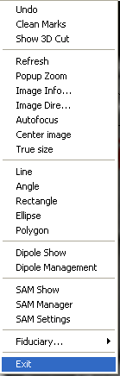
Image Analysis Popup Menu

This menu is a combination of the Edit, View and Analysis menus in the window. The functions are same to them. Please read the corresponding section for details.

