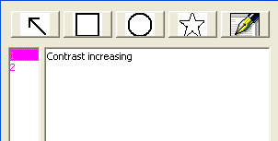
Notes Window for Image Analysis

This toolbar provides the function for making notes for 2D image(s) with various signs and colors.

The left list will show all the notes; and the right text box will display the context of the notes.

The Arrow, rectangle, ellipse and polygon represents the symbol can be used for notes. The pen is used to define the color and size of pen used in drawing the symbol.

