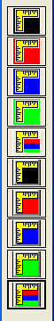
Statistic Toolbar for Image Analysis

This toolbar provides the function for statistically counting the visible points and marked points. Please pay special attention to the color, which indicates the current counting points. Black indicates visible and non-visible points; Red, Mark1; Blue, Mark2; Yellow, Mark3. The low four buttons seems 3D buttons; they work for 3D images.

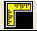
It is designed for calculating visible and none-visible points for the 2D image.

It counts the Mark1 Points (red) for the 2D image.

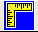
It counts the Mark2 Points (blue) for the 2D image .

It counts the Mark3 Points (green) for the 2D image.
It counts the all Marked Points for the 2D image.

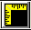
It is designed for calculating visible and none-visible points for the 3D image.

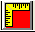
It counts the Mark1 Points (red) for the 3D image.

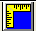
It counts the Mark2 Points (blue) for the 3D image .

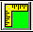
It counts the Mark3 Points (green) for the 3D image.

It counts all Marks points for the 3D image.

