Analysis Professional Window

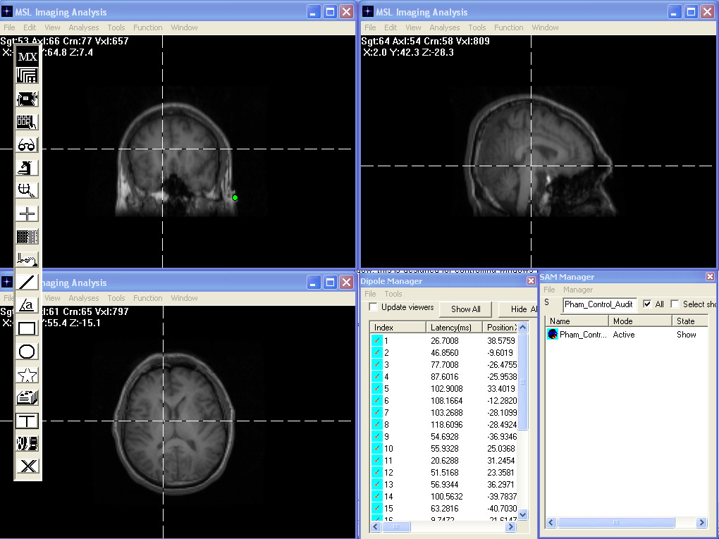

The Professional Analysis has three windows for analyzing 2D images in three views. The three windows allow user to analyze images more easily. In professional analysis, user can use one toolbar to analyze three images.

To decide if and how the functional images can be overlapped onto structural images, the Dipole and SAM mangers are accessible in the Professional Analysis mode. The functions of each window are exactly same as the standard window. Please see the standard window for details.

