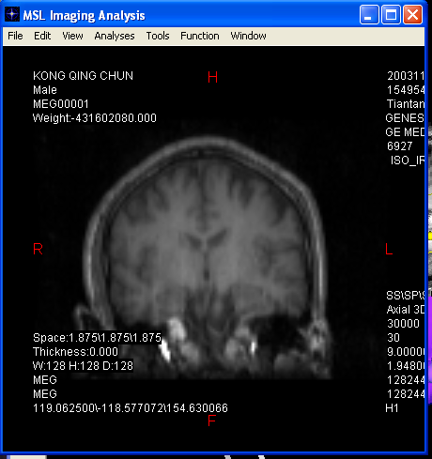
Analysis Standard Window

The Analysis Standard window allows users to analyze the image in 2D view. Users can arrange the images and do various measurements.

The major functions in image analysis can be accessed using menus. The main manus are listed as followings.

Menu File
When you finish your work, go to file and exit. If you ask me why don’t make new button or Ok button, I would like to say that this would provide more space for segmentation or most frequently used tools.

Menu Edit
This menu allows users to edit the image includes undoing previous work, cleaning Marks, editing slices and synchronizing the 2D selection with the 3D selector.

Menu View
To control how to view the 2D images, using the menu to select various functions. The functions include View Plane, view Control, View Position, Image Zoom, Image Transform, Image Dimension, Image Codes, Popup Zoom, Image Information, Image Settings, Text Settings, Text Font, Background, Full Screen and Refresh.

Menu Analyses
This menu includes most of the functions of 2D image analysis. Those functions include Line to measure distance, Angle to measure angles, Rectangle to measure the area of a rectangle, Ellipse to measure the area of a ellipse, Polygon to measure the area of a polygon, and Histogram to show the histogram of the active image.

Menu Tools
Menu Tools provides a way for use to show a few functional toolbars or dialogs. The main toolbars are Basic for basic toolbar, Pixel for pixel processing (Same as the Segment Dialog which processes pixels), Statistics for statistically calculating the marked pixel or voxel (in 3-D), Report and Notes.

Menu Function
This menu is designed for control ling the functional images such as dipoles and SAM. It allows easily showing/hiding dipoles and/or SAM images. Furthermore, it provides the accesses for showing Dipole and SAM managers. The Fiduciary menu is used for adding fiduciary points for 3-D integration of multimodal integration.

Menu Window
This is designed for controlling windows in Professional Image Analysis.

