SAM Analysis Window
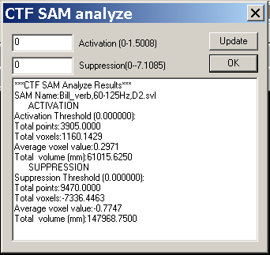

SAM information can be statistically analyzed with this function.

The SAM analysis window will calculate all SAM point, voxel value (it can be T, Z or any SAM value). The SAM information is divided as two groups: activation and suppression. Each group has four parameters: total points, total voxel, average voxel and total volume.
Please note that the total points are effected by the step (or space in X, Y and Z direction).

Hint: you can input the active or suppressive number in the Activation and Suppression text boxes, and press the Update button. Then the SAM data will be re-analyzed and display to you the new results.

