SAM Peak Mark Window
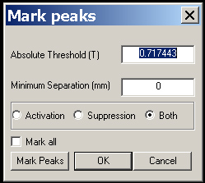

In the Mark Peaks window, user can easily find the peaks.

Absolute Threshold: the Absolute Threshold (T) indicates the SAM value (such as T or Z) at which can be marked.

Minimum Separation: The Minimum Separation indicates how far of the two SAM peaks.

You can mark either Activation (s) or Suppression or both. If you checked the Mark all, then the marking action will be applied to all SAM files.

The Mark Peaks button marks the peaks.

