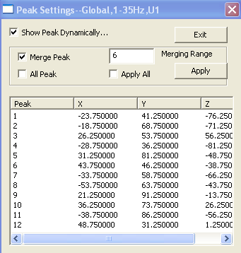
SAM Peak Settings

Each SAM image can have many peaks. Each peak represents an active area. The
Peak Settings dialog allows user to define how the peak will be showed in 3D and 2D viewer.

Show Peak Dynamically: If it is checked, when user select a peak in the peak list, the program will automatically show the peak in 3D and 2D viewer.

Merge Peak: by the default, SAM image is generally merged into MRI/CT with the SAM voxel. It shows nice range and focal increase of spectral power. However, it may make the peak unclear if the one or more peaks are too strong. To show the SAM peaks more clear, this function allows show the peaks alone without using the SAM voxel.

Merging Range: It defines how big each peak will be display in 2D and/or 3D viewer.

All Peaks: It allows user to show all peaks in one 2D and/or 3D viewer.

Apply All : It applies changes to all the SAM images.

Apply: It applies the changes to the current viewers.

The list shows all the peaks in the selected SAM image. User can select the SAM image in the SAM Manager Dialog.

Peak: the peak column in the list shows the order of the peaks.

X, Y and Z: the x, y and z indicate the position of the peak.

