SAM Selector

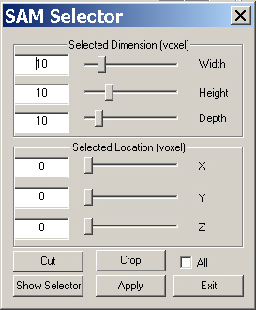

SAM Selector provides a window for editing SAM imaging, such as group cut and crop.

The SAM Selector provides an interface for editing SAM images. The main functions are cutting and cropping the selected area.

Selected Dimension: These three parameters decide the size or extent of the select area. Please note that the dimension is described with “voxel”, not exact size. You can calculate the exact size by applying the space distance (in SAM, it is called “step”) in X, Y and Z direction. For example, the exact X Dimension = Voxel X SpaceX.

Selected Location: The three parameters in this group decide the location of the selected area. Please note that the dimension is described with “voxel”, not exact location. You can calculate the exact location by applying the space distance (in SAM, it is called “step”) in X, Y and Z direction. For example, the exact X Dimension = Voxel X SpaceX.

Cut: This function will cut the selected area.
Crop: This function will crop the selected are that means cut the non-selected area.

All: If the check box is checked, then all the cutting and cropping functions will apply to all SAM files.

Show or Hide: The show or hide button will toggle the selector frame.

Apply: this button will apply all changes to the SAM(s).

Exit: this button will close the window.

