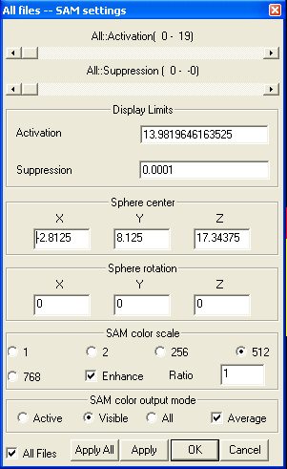
SAM Settings

SAM Settings menu invokes a SAM settings window, which allows you to set various parameters for display SAM images.

Active Scroll Bar: This scroll bar controls the display range of activation of SAM image. The activation in here is the value (such T or Z) above 0.

Suppression Scroll Bar: This scroll bar controls the display range of suppression of SAM image. The suppresion here is the value below 0.

Display Limits: The display limits is used for “turn around” the SAM imaging. It displays all SAM voxel above the limits as the same color. For example, if 8 shows as white, 7 shows as yellow and 6 shows as red. If there is a limit and it is 6. Then all number above 6 are showing as white.

Activation: The display maximum value of the active SAM value.

Suppression: The display minimum value of the active SAM value.

Sphere Center: This is used to shift all the SAM images.

Sphere Rotation: It is used for rotating the whole SAM images.

SAM Color Scale: SAM image can be displayed as various ways; this is accomplished by selecting color scale here.

1: the entire SAM image will be displayed as one color, it does not matter the voxel is active or suppressive.

2: the entire SAM image will be displayed as two colors; one for active and another for suppressive.

256: the entire SAM image will be displayed as two groups of colours, one for active and another for suppressive. Each group will be divided into 256 scales.

512: the entire SAM image will be displayed as two groups of colours, one for active and another for suppressive. Each group will be divided into 512 scales.

768: the entire SAM image will be displayed as two groups of colours, one for active and another for suppressive. Each group will be divided into 768 scales.

Enhance: the SAM color will be enhanced in the integrated image.

Ratio: the ratio of SAM value into SAM color.

SAM Color Output Mode: This functionality is for merging SAM color into MRI. The out put color can be Active SAM file (which can be identified in SAM manager) or Visible SAM file that means the display SAM files. All SAM files indicate the output color from all SAM files. The Average check box is used to decide how the output color be produced, by average all color and then output or not.

All Files: If this checkbox is checked, all above actions are applied to all SAM files. It is recommended for most of cases.

Apply All and Apply: Apply All button will apply the changes to all SAM files, while the Apply button only apply the changes to active SAM file.

