SAM Transfer Window
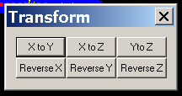
All SAM images can be transferred by using this function. It can change SAM direction and axis. This window allows you change the co-ordinate of the SAM data sets. You can reverse and exchange X, Y and Z coordinates by clicking the corresponding buttons.

ReverseX: The button will let reverse the data in X-axis for all data.

ReverseY: It will reverse the data in Y-axis for all data.

ReverseZ: It will reverse the data in Z-axis for all data.

XtoY: It will exchange X value to Y valued for all data.

XtoZ: It will exchange X value to Z value for all data. The button will change prompt and temporally.

YtoZ: It will exchange Y value to Z valued for all data.

