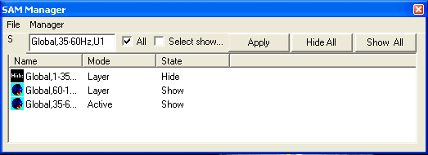
SAM Manager

The SAM Manager provides an easy-to-understand interface for manipulating SAM images.

At the left up corner, there is a small color icon indicates the color type of the SAM imaging. If you would like to apply one action to all some images, select the check box. A change will be applied to all SAM images.

All: it will allow that the changes can be applied to all SAM items.

Select Show: it will automatically show the selected item on the 3D and 2D view.

Apply: it applies the changes to the SAM item(s).

Hide All: This function will hide all the SAM images.

Show All: This function will show all the SAM images.

File Menu

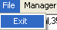
It allows the user to hide the manager window.

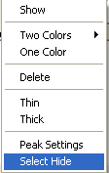
Manager Menu

Several functions are available by pressing the right mouse button or selecting the Manager Menu.

Show: it shows or hides the selected SAM images.

Two color: it allows for selecting two colours for SAM image(s): one for Active Voxels and one for Suppressive Voxels.

One color: it allows for selecting one colour for SAM image(s), one for both Active Voxels and Suppressive Voxels.

Delete: it deletes the selected SAM image(s).

Thin: it allows user to change the density of the imaging. It is designed for very experienced users.

Thick: it allows user to change the density of the imaging, make it thicker. It is designed for very experienced users.

Peak Settings: it allows user to define how the peak will be displayed. Please note that the image in the Peak Setting dialog will change accordingly as user selects in the Manager Dialog.

Select Hide: If this menu is selected, the region selected will be hidden in the 3D show.

