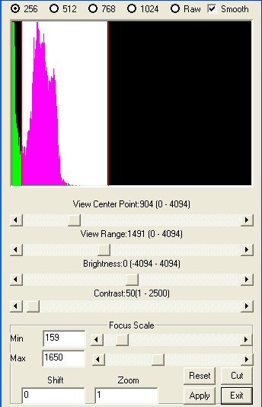
2D Display Settings

The main part of the 2D view settings is the focus scale. As you know, medical imaging may have a wide range of data gray scale. This program provides several ways to view the data. It can map the data to a range from 256 to 1024, or you can view the data as raw that means no mapping at all. If you view data as raw, you may see nothing. Therefore, you need to adjust the view pointer and view range to find the interesting data.
There are several advanced functions for advanced users. That is the “cramp” or “confine” of the data. You can confine the data and show the confined data in the suitable focus scale.

Hint: We can consider the data of medical imaging as a wide gray scale; this is the first scale, such as 0 – 1000. Then, this program help you confine the data to 500 – 1000, we are assuming this range shows bones, the we map 500 – 1000 to either 250 or 1024, so as to see different kinds of bones. Therefore, these settings provide third grad adjusting. It is really very powerful if you fully understand the user interface and know what you would like to find out in you medical imaging.

The View Pointer, View Range, Brightness and Contrast functions are only available for raw view. The functions in this window provide better user face and show the exact numbers, it better than the corresponding menu function. Certainly, it is just a matter of taste. Please note that, the internal functions are same as the menu versions, respectively.

