Slice and Volume Space Settings
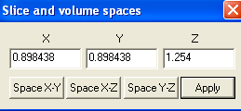

This function is designed for correcting or changing the distance between points (pixel in 2D or voxel in 3D). For same reason, 3D images may have wrong space values or the values are missed up. In this case, Space function can be used.

In the Space dialog, the X, Y and Z represent the space in three directions. Once you changed the value, you can see the results by pressing the Apply button. You can exchange the space use the X-Y, X-Z and Y-Z buttons.

Hint: You should try to avoid using this function because the MRI or CT systems generally produce it. It provided for advanced users for correcting distortions when he or she knows how the original data acquired.

