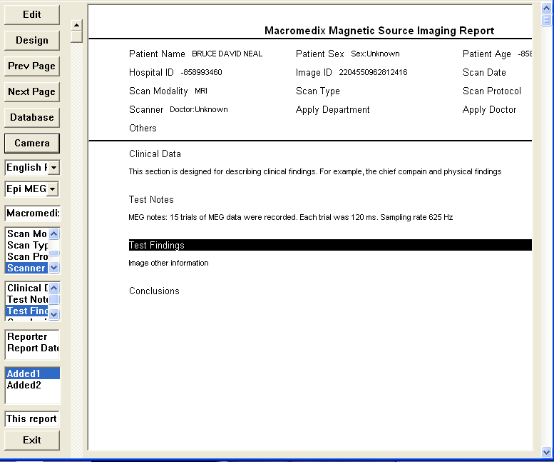
Medical Imaging Report

The report window can be connected to enterprise Database through network. Users can edit the report by double clicking the corresponding items.

