Structure Coordinate Window
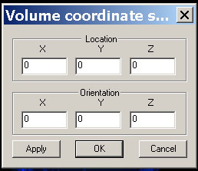

This window allows user to change the location and orientation of the 3D coordinate of the volume data. Generally speaking, this function is used only by super user for specific purpose.

