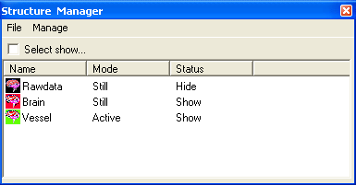
Structural Item Manager

Structural Item Manager is designed for managing all structural data items (or volume items). It displays all available structure data; the titles for the structural items are listed for easily identifying the components. You can hide (or display), delete and edit all volume data in the Manager Window.

Name: The Name indicates the volume data name that is given by users.

Mode: The Mode indicates the volume data item is active or layer. Active indicates the item is currently editable, any action work on one volume data will be directed to this structural data. Still can be displayed or hidden or deleted, however, it is not the active item which may be editing. Therefore, other action, such as segmentation will not be conveyed to this item. Therefore, always check the Manager to confirm you are working on the right one.

State: It indicates if the volume item is visible or not.

Select View: When it is checked, only the selected item is visible. It is dynamically changing as mouse or key moving through the list.

Menu File
It allows user to hide the manager window by selecting “Exit”.

Menu Manage
It provides many functions for managing the structural data.
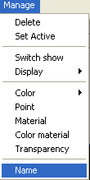
Popup Menu: Pressing right mouse button invokes this Popup Menu. However, the functions are exactly same as Manage menu. So, just take the way you like the best.

Manage Functions
There are several functions are directly acting on the selected item. Here, the selected item points to the active one. You can check it under the Mode list.

Delete: it deletes the currently selected item.

Set Active: it set the selected item as the working item, so that all segmentation or processing will be working on this item.

Switch Show: If it is displayed, then it will be hidden, otherwise, it will be displayed. It simply toggles showing or hiding.

Display: If some points have been marked, you can select either showing all points or just showing marked points.

Color: If some points have been marked, you can select one of your favorite colors for all points or just marked points.

Blend: It is one kind of display options. You can try either one depending on what kind of view you persuade.

Transparency: For some specific purposes, you like some material to be transparent. You can check this function, enable transparency and adjust the transparent value.
Material: For each volume item, you can set it as a specific material. Many characteristics can be adjusted.
Color Material: Similar to material, generally it is not used.

Point: The function is only effecting on the volume rendering. In volume rendering, each visible point is displayed, and you can adjust the size of point.

Name: For each volume item, you can give it a meaningful name. Try to make it easy to understand and remember.

