Normal Setting Window
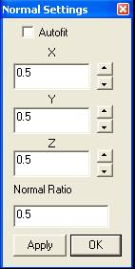

The Normal window is designed for advanced or power users to change the OpenGL normal values. It can change the 3D rendering characteristics.

Autofit: it will automatically change the normal.

X, Y and Z: it changes the values of the normal in three directions.

Normal Ratio: it adjusts the ratio of normal.

Apply: it applies the changes to the rendering.

