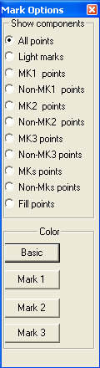
Render Options Window

The Render Option is very useful when user has marked a specific structural item (tissue). Please note that the render options indicate the “component” within each item in the Manager list. Therefore, a structural data (anatomical data set) has several tissues (items in the Structural Manager), each tissue has several rendering components. This “tree” and “list” construction can be used in displaying very complicated human body with functional and anatomical information.

The render components include MK1, MK2 , MK3 and All (MKs). To display any possible single component or combination, the Render Options provides all with build-in radio check for you to select.

Users can check the range of gray scale and use the full range in the 3D rendering. Further more, users can change the color of the Marks.

All Points
It shows all the points without considering if they are marked.

Light Marks
It shows all the points without various colors to indicate the marked points.

MK1
It shows all the points with MK1.

Non-MK1
It shows all the points without MK1.

MK2
It shows all the points with MK2.

Non-MK2
It shows all the points without MK2.

MK3
It shows all the points with MK3.

Non-MK3
It shows all the points without MK3.

MKs
It shows all the points with any marks.

Non-MK3
It shows all the points without any marks.

Fill Points
It shows all the low filled points; they are special kinds of marked points.

Color
The buttons in the color group are used to define the colors for marks. They are provided for super user.

Basic
It changes the color for non-marked basic points.

Mark 1
It changes the color for Mark 1 points.
Mark 2
It changes the color for Mark 2 points.

Mark 3
It changes the color for Mark 3 points.

