Superview
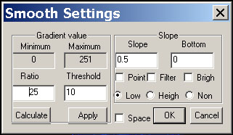

The Superview functions are used by power users. It provides more details of 3D rendering parameter for better rendering.

You can set all parameters manually and apply it by clicking the Apply button.

