Structural Transform Window
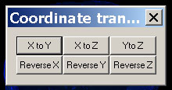

The Transform Window allows transforming the three-dimensional coordinates of the active volume item (Please refer to Structural Manager for more details of active item).

X to Y, X to Z and Y to Z: These three buttons will exchange the coordinate system according to the label indicated, respectively.

Reverse X, Reverse Y and Reverse Z: These three buttons will reverse the coordinate system according to the label indicated, respectively.

