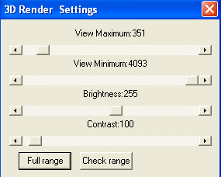
3D Voxel Settings Window

The 3D Render Settings is to set the visible range of the gray scale of the volume data and define how the tissue(s) should be displayed.

The Minimum and Maximum slide bars are used to control the visible range. The areas, actually the points, which are outside of the visible range, are not displayed, they are hidden. This is very useful for showing the interesting tissues, like bone or vessel.

The Brightness and Contrast are used to define the brightness and contrast of the rendering of the gray scale data.

