**EXPERIMENT TITLE**: APPLY BUG TRACKING TOOL

**OBJECTIVE**:

1. TO CREATE PROJECTS & USERS
2. TO ASSIGN BUGS
3. TO GENERATE REPORTS

STEP 1 : CREATE A FREE TRAIL ACCOUNT ON ZOHO BUG TRACKER

STEP 2 : ASSIGN SUITABLE PROJECT NAME WHILE CREATING ACCT

STEP 3: ADD USERS WITH DIFFERENT ROLES SUCH AS ADMIN, MANAGER,EMPLOYEE…

STEP 4:SELECT A BUG FROM “OPEN BUGS” & CHANGE THE ASSIGNEE TO YOUR TEAM MEMBER

STEP 5:WHILE ASSINGNING BUGS CHANGE THE VALUES WHEREVER APPLICABLE.

STEP 6: ADD VALUES TO MILESTONES

STEP 7 : ADD VALUES TO TIMESHEET

STEP 8 : EXPLORE “FEED”,”STATUS” &”ACTIVITY”

STEP 9: CLICK ON BASIC REPORTS :-STATUS, ASSIGNEE.

STEP 10:CLICK ON ADVANCED REPORTS :- ASSIGNEE WISE BUG STATUS,CUSTOM BUG REPORT

STEP 11: ASSIGN DIFFERENT PHASES THROUGH CALENDAR

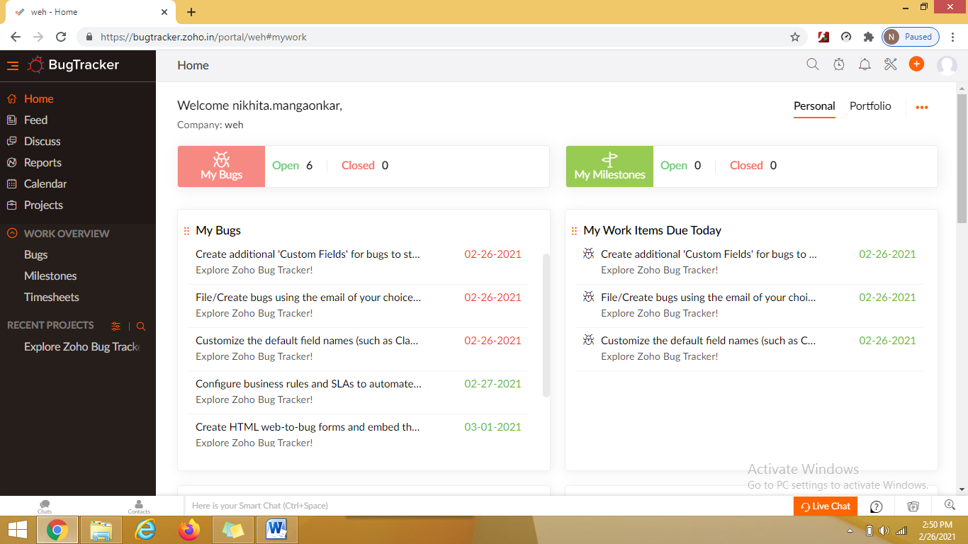Screen1: Homepage for Bugtracker tool

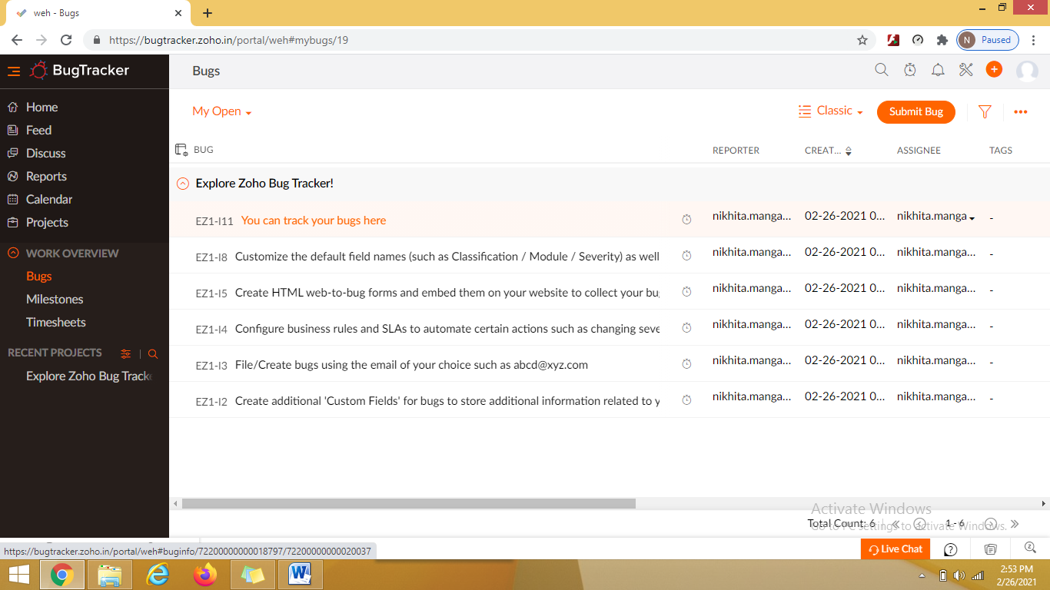

Screen 2 : “Open” tab for assigning bugs

