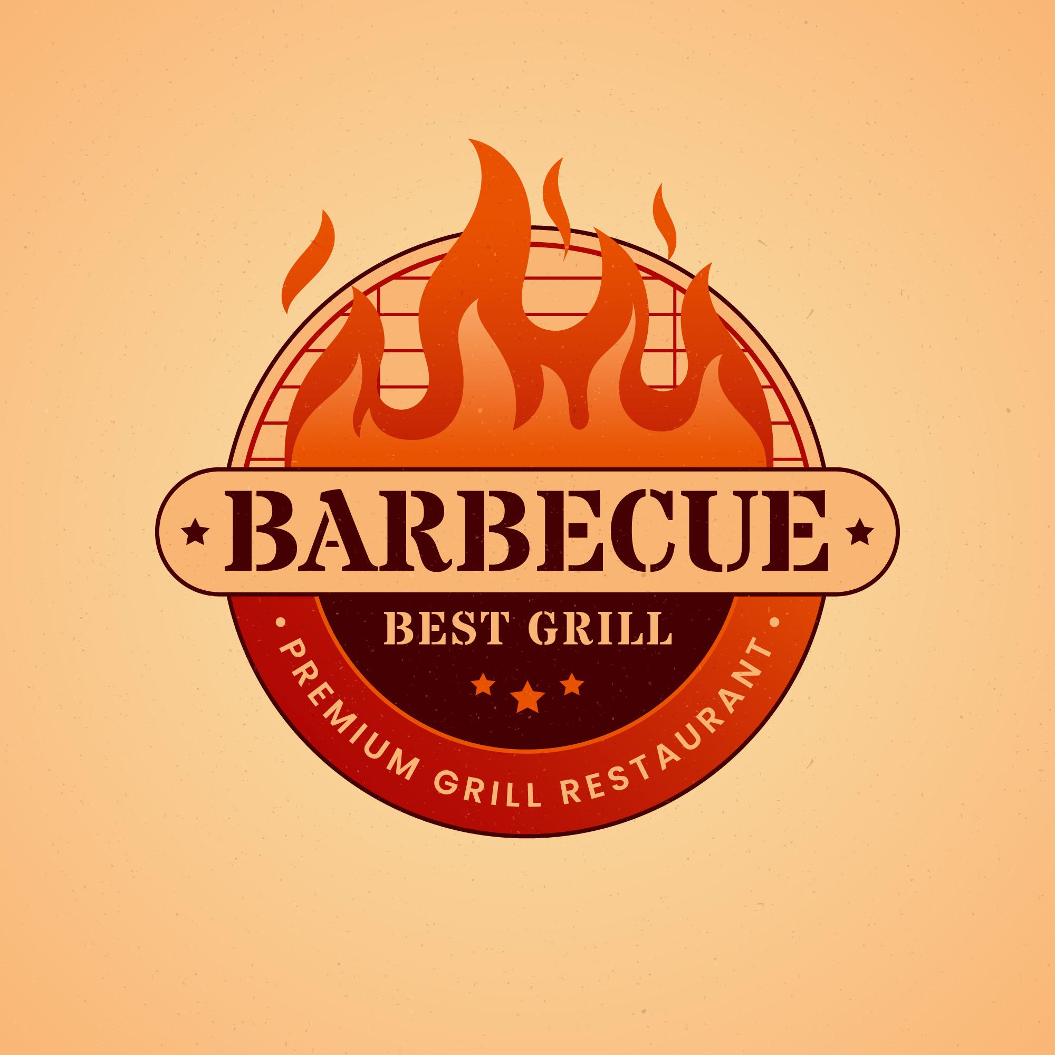
About US
My name is Annabell Wilson and current owner and proprietor. We are a family-owned business since 1987. First established by my grandfather and grandmother. They loved to barbecue, and they pass that love to their son and he passed it to me. We look for high-quality meats and vegatables, if they don’t meet ours standards we don’t cook it or use it. We have different homemade special sauces and drinks to tailor and compare with different entress and dishes. Come join us and see for yourself.

3465 Ave. Street
North Chicago, IL. 60078-1234
Ph: (555) 555-5555

