🎮 Game Platform - Complete Documentation
📋 Overview
Game Platform is an interactive multiplayer game application built with modern web technologies. Currently featuring Tic-Tac-Toe with both single-player (vs Computer AI) and multiplayer modes.
Key Features
- ✅ Real-time multiplayer gameplay using Socket.IO
- ✅ Single-player mode with intelligent computer opponent (Minimax algorithm)
- ✅ Responsive UI with Tailwind CSS
- ✅ Modular architecture for easy game expansion
- ✅ Server-side game logic validation
- ✅ Room-based game management

🏗️ Architecture
Frontend Stack
- React 19 - UI framework
- Vite - Build tool & dev server
- Tailwind CSS - Styling
- Socket.IO Client - Real-time communication
- Zustand - State management
- React Router - Client-side routing
Backend Stack
- Node.js - Runtime
- Express.js - HTTP server
- Socket.IO - WebSocket communication
- Nodemon - Development auto-reload
Shared
- Constants - Shared event names and game rules

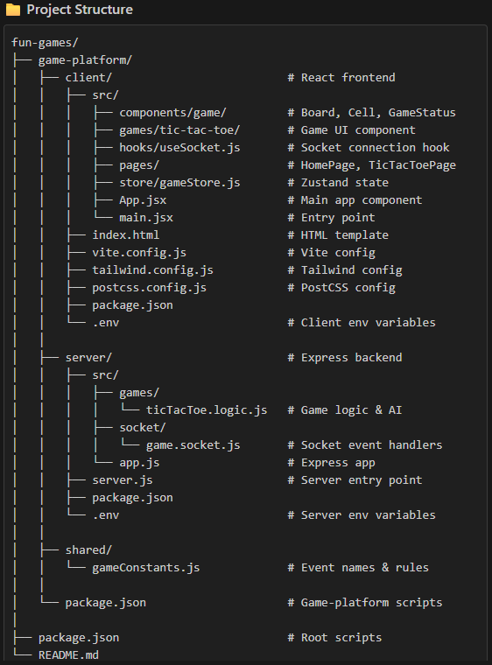
🚀 Running the Application from VS Code
Prerequisites
- Node.js v16+ installed
- npm v8+ installed
- Visual Studio Code installed
Step-by-Step Setup
1️⃣ Open Project in VS Code
# Open VS Code and load the project
code D:\Projects\fun-games

Or use VS Code's File → Open Folder → Select fun-games
2️⃣ Open Integrated Terminal
In VS Code:
- Press Ctrl + (backtick) to open integrated terminal
- Or go to View → Terminal
3️⃣ Install Dependencies
npm run install-all

This installs:
- Root dependencies
- Game-platform dependencies
- Server dependencies
- Client dependencies
Expected output:

4️⃣ Start Development Servers
npm run dev
Expected console output:
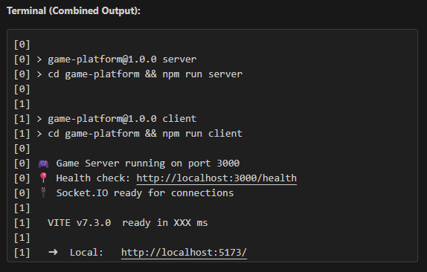
5️⃣ Access the Application
- Frontend: Open http://localhost:5173 in your browser
- Backend Health Check: http://localhost:3000/health

🎮 How to Play
Home Page
- Click 🤖 Play vs Computer to play against AI
- Click 👥 Create Multiplayer Game to create a room for friends
- Enter a Room ID and click Join Multiplayer to join an existing game

Game Rules
- Tic-Tac-Toe: First player to get 3 in a row (horizontal, vertical, or diagonal) wins
- You: Always play as X
- Computer/Opponent: Plays as O
- Draw: If all 9 cells are filled with no winner
Controls
- Click any empty cell to make your move
- Computer moves automatically after 1 second
- Click "Play Again" to start a new game

