Ques 1: Below is a small flask app with a Dockerfile your task is to explain the Dockerfile and then make a change in the app.py file and change your name in “My name is ___” string, then create a Docker Image and push it to docker hub.After building that docker image your name should be shown at that place.  
  
For a successful submission share docker hub link and a screenshot to the webpage.

Find the code from here: <https://github.com/DARK-art108/Dockerfile-Assignment>

Dockerfile explaination:

FROM ubuntu:20.04: **This line means install Ubuntu version 20.04 from dockerhub**

RUN apt-get update && apt-get install -y python3 python3-pip: **This line means to first update the system and then install python3, after installing python3 install pip using python3**

RUN pip install flask: **This line means to install flask using pip which we installed in 2nd step.**

COPY app.py /opt/: **This line means to copy app.py file to opt directory in the docker image**

ENTRYPOINT FLASK_APP=/opt/app.py flask run --host=0.0.0.0 --port=8080 : **The ENTRYPOINT command starts the flask application when you run the docker container and it exposes port 8080, so that application is accessible on port 8080.**

**Screenshot after running docker container:**

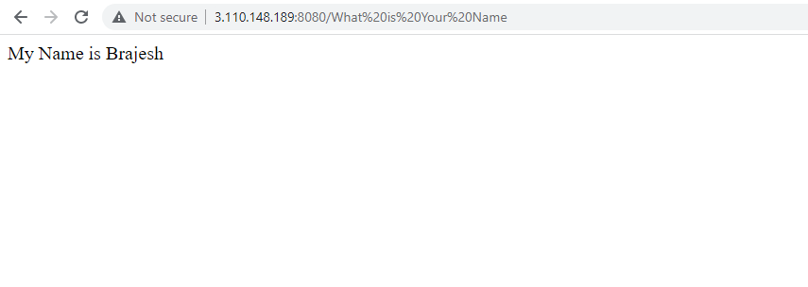

**https://hub.docker.com/repository/docker/brajeshkaushik/flask_assignment/general**

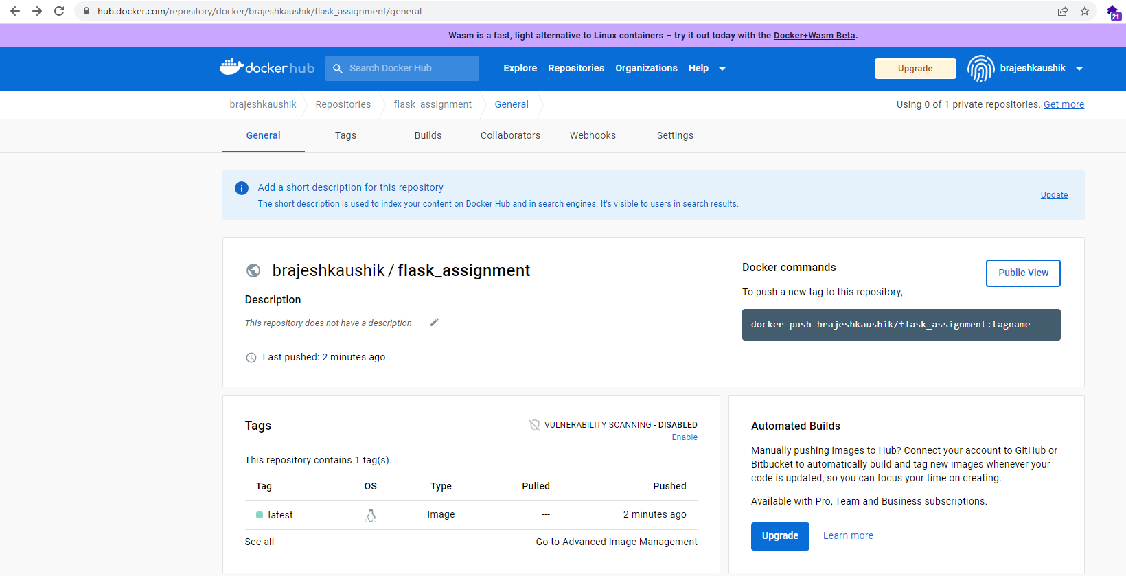

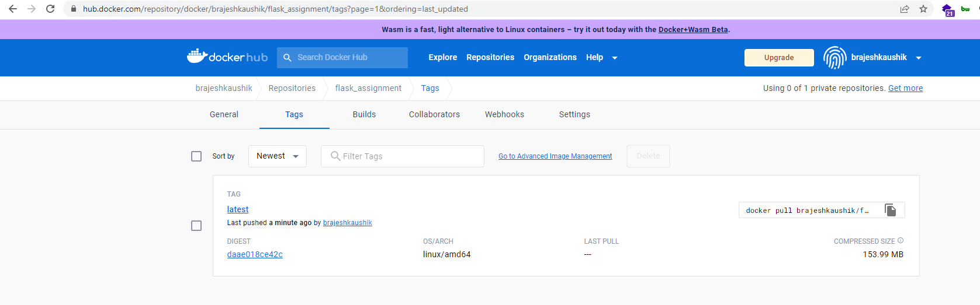

**docker pull brajeshkaushik/flask_assignment:latest**