

**Basic Linux Commands Assignments**

Assignment-1

Connect and disconnect with login Access

* What happens when you login a non-existent users or username?
  + Provide Screenshot and What you understand, explain in short brief?

**Solution:** When we are trying to switch user using **su** **username** command, if the user exists it will ask for password otherwise it will show error user username does not exist.

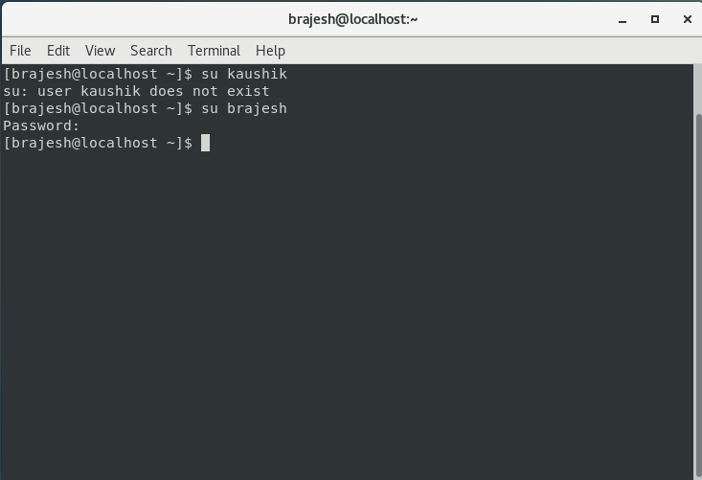

Assignment-2

Password changing

* Login into your account and then change password?
  + Change your password into **IneuR0n#42** and hit the **Enter** key
    - Explain what happen and give screenshot?

**Solution:** Password changed successfully to **IneuR0n#42**

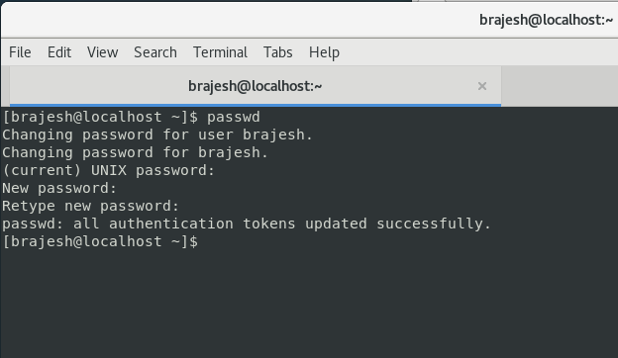

* + Try again to change password but use like password ***1234*** or ***abcd***
    - Explain what happen and give screenshot?

**Solution:** Since the password is very small and weak terminal gives this error message The password is shorter than 8 characters.

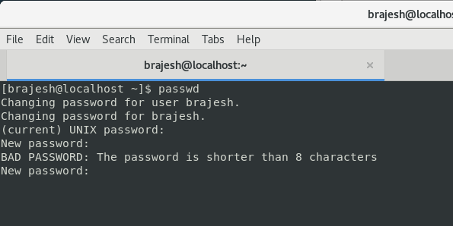

* + Try again to change password but now don’t use any password just hit **Enter** key
    - Explain what happen and give screenshot?

**Solution:** When providing no password it gives error message no password supplied

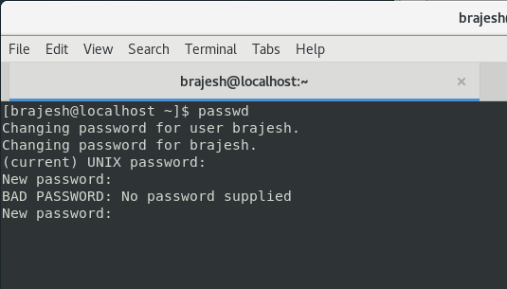

Assignment-3

Working with Directories

* Enter the command **cd /** and then **ls** and then hit **Enter** key
  + Take screenshot and explain what output we got?

**Solution**: this command is used to change directory to the root directory, The root directory is the first directory in your filesystem hierarchy.

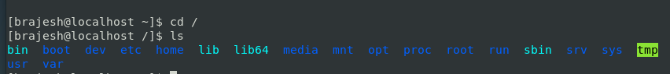

* Enter the command now **cd /home** and then hit **Enter** key
  + Do **ls,** provide screenshot and explain what is **/home** directory used for?

**Solution:** The Linux home directory is a directory for a particular user of the system and consists of individual files. It is also referred to as the **login directory**. This is the first place that occurs after logging into a Linux system. It is automatically created as **"/home"** for each user in the directory



* Enter **cd ..** and hit **Enter** key [ *Note: here we have space after cd then use double dot*]
  + Check what happen and give screenshot?

**Solution:** When a user enters cd .. in home directory they are redirected to root directory

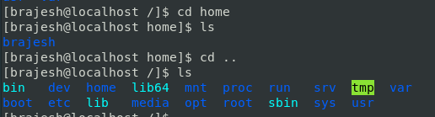

* Now enter **cd /var/www/html** and then type **cd** and hit **Enter** key
  + Explain what happen and give screenshot?

**Solution:** It navigates to the home directory

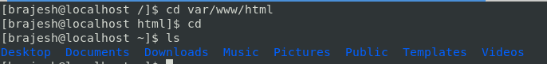

* Now type **cd /root** and then hit **Enter** key
  + Do **ls,** check any output we have on screen if yes then take screenshot?

**Solution:**

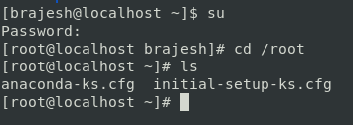

Assignment-4

Working with File Listing

* Go to **cd /etc** and type **ls**
  + Take screenshot and explain what files you have seeing?

**Solution:** The /etc directory is where a Linux system's configuration files live. **ls** command shows list of configuration files

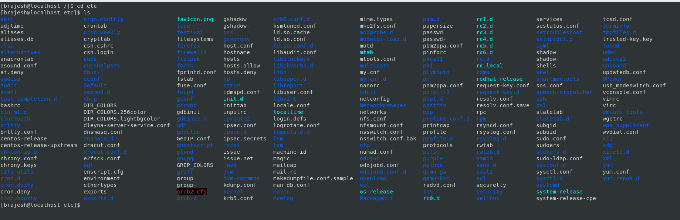

* + Take screenshot and explain what different output you found compare to previous command you used?

**Solution: ls -l** command shows the full details of the configuration files whether it is a directory or file.

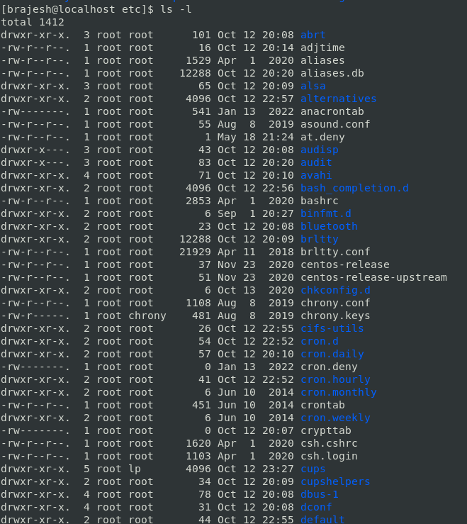

* Then type **ls -al** and hit **Enter** key
  + Take screenshot and explain what new file or directory you found?

**Solution: ls -al** command lists all the files even the hidden files.

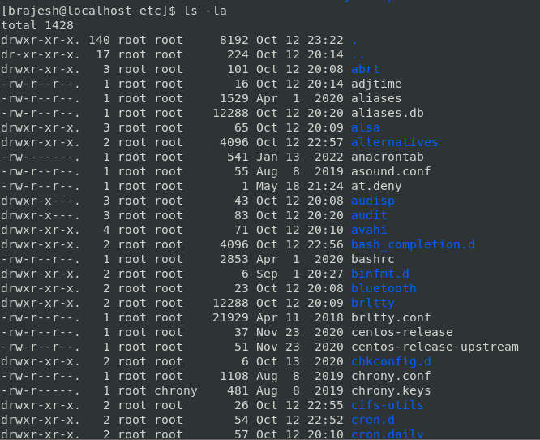

The hidden directories we found are: .pwd.lock, .updated





* Then use **ls -i** and hit **Enter** key
  + Now see what different output its shows and take screenshot?

**Solution:** ls -i prints the index number of each file

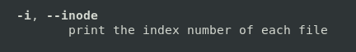

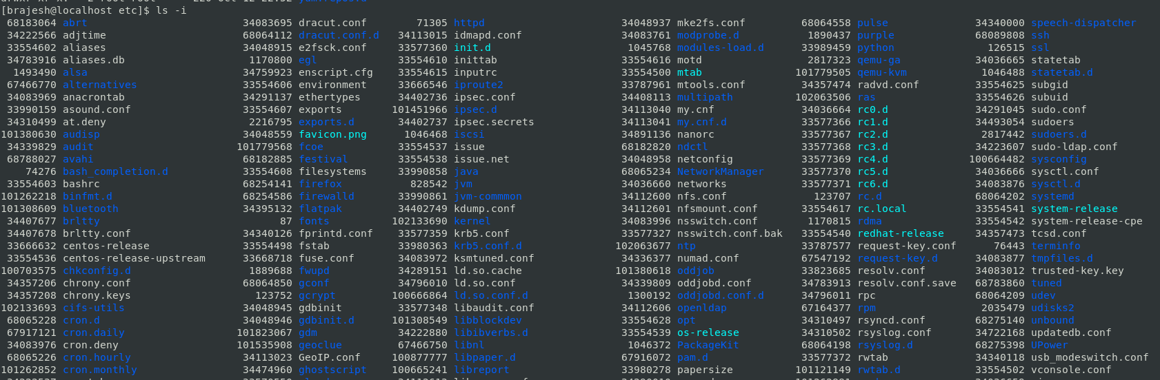

* Then use **ls –help** and see other options about **ls** command
  + Explore it and try with other attribute we can use with **ls** command

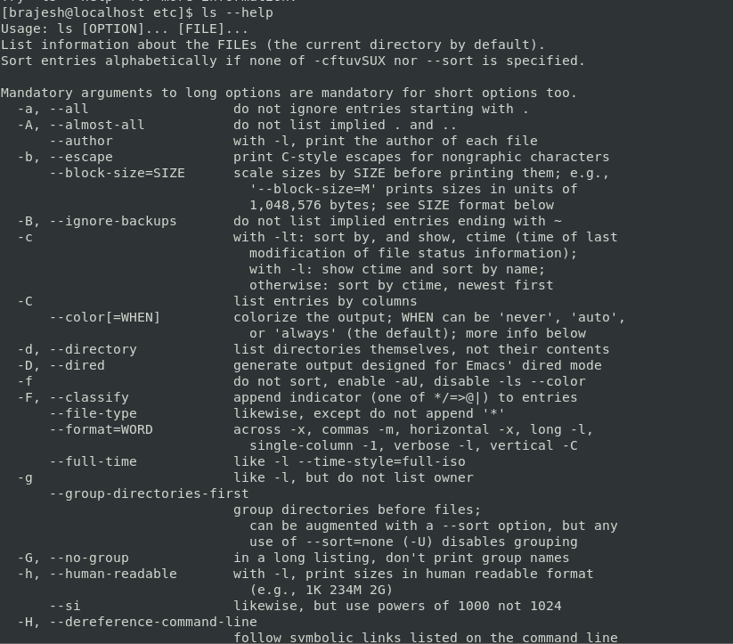

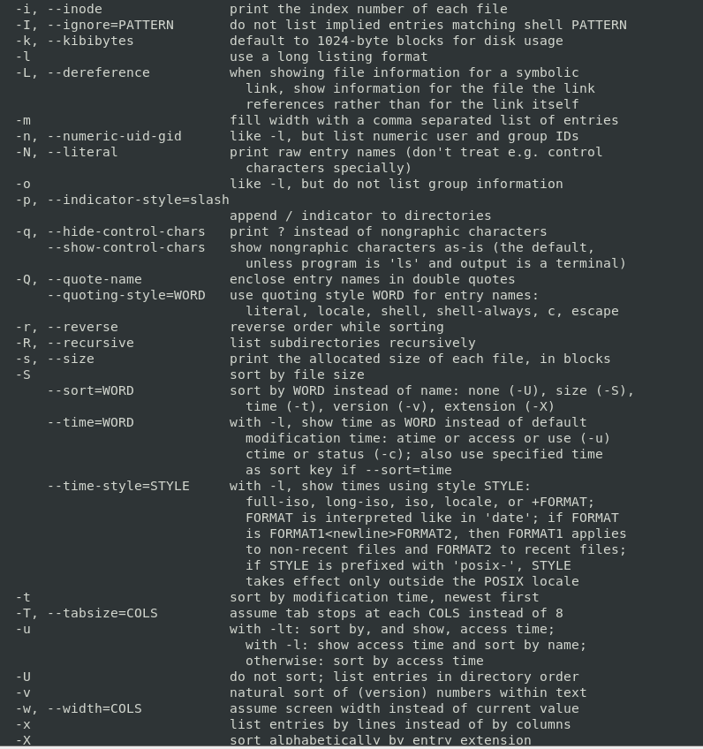

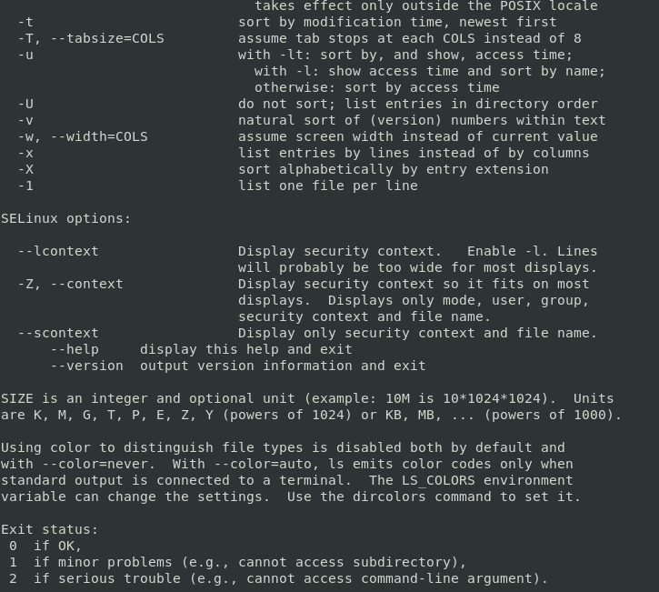

Assignment-5

Know where you are and where you working

*Here we use* ***pwd, cd and ls*** *as combine task to understand where you working on terminal and how you can switch from one directory to another one.*

* Open terminal after restart the linux
  + Check which location you working, type **pwd** and take screenshot

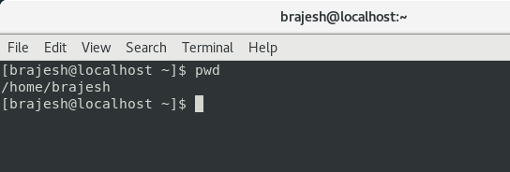

* Now use **cd /var** and hit **Enter** key
  + Do **ls,** and see what output comes, give screenshot?

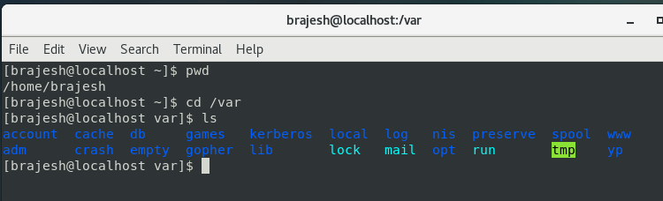

* Do explore other help options of each command to learn more other things we can do with these commands

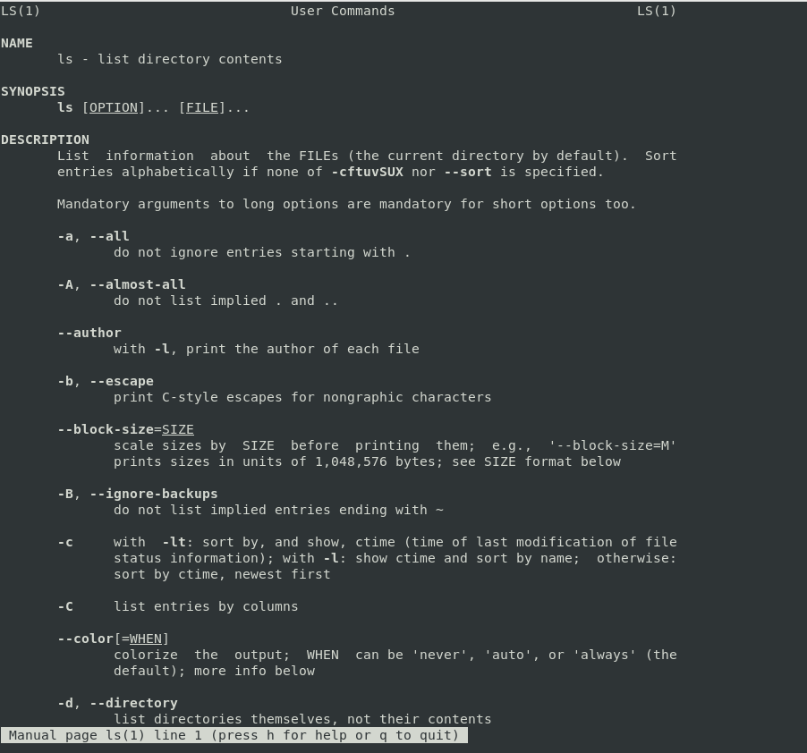

Class Assignments:

1. Assignment 1: - Install all the dependencies for making CentOS full screen

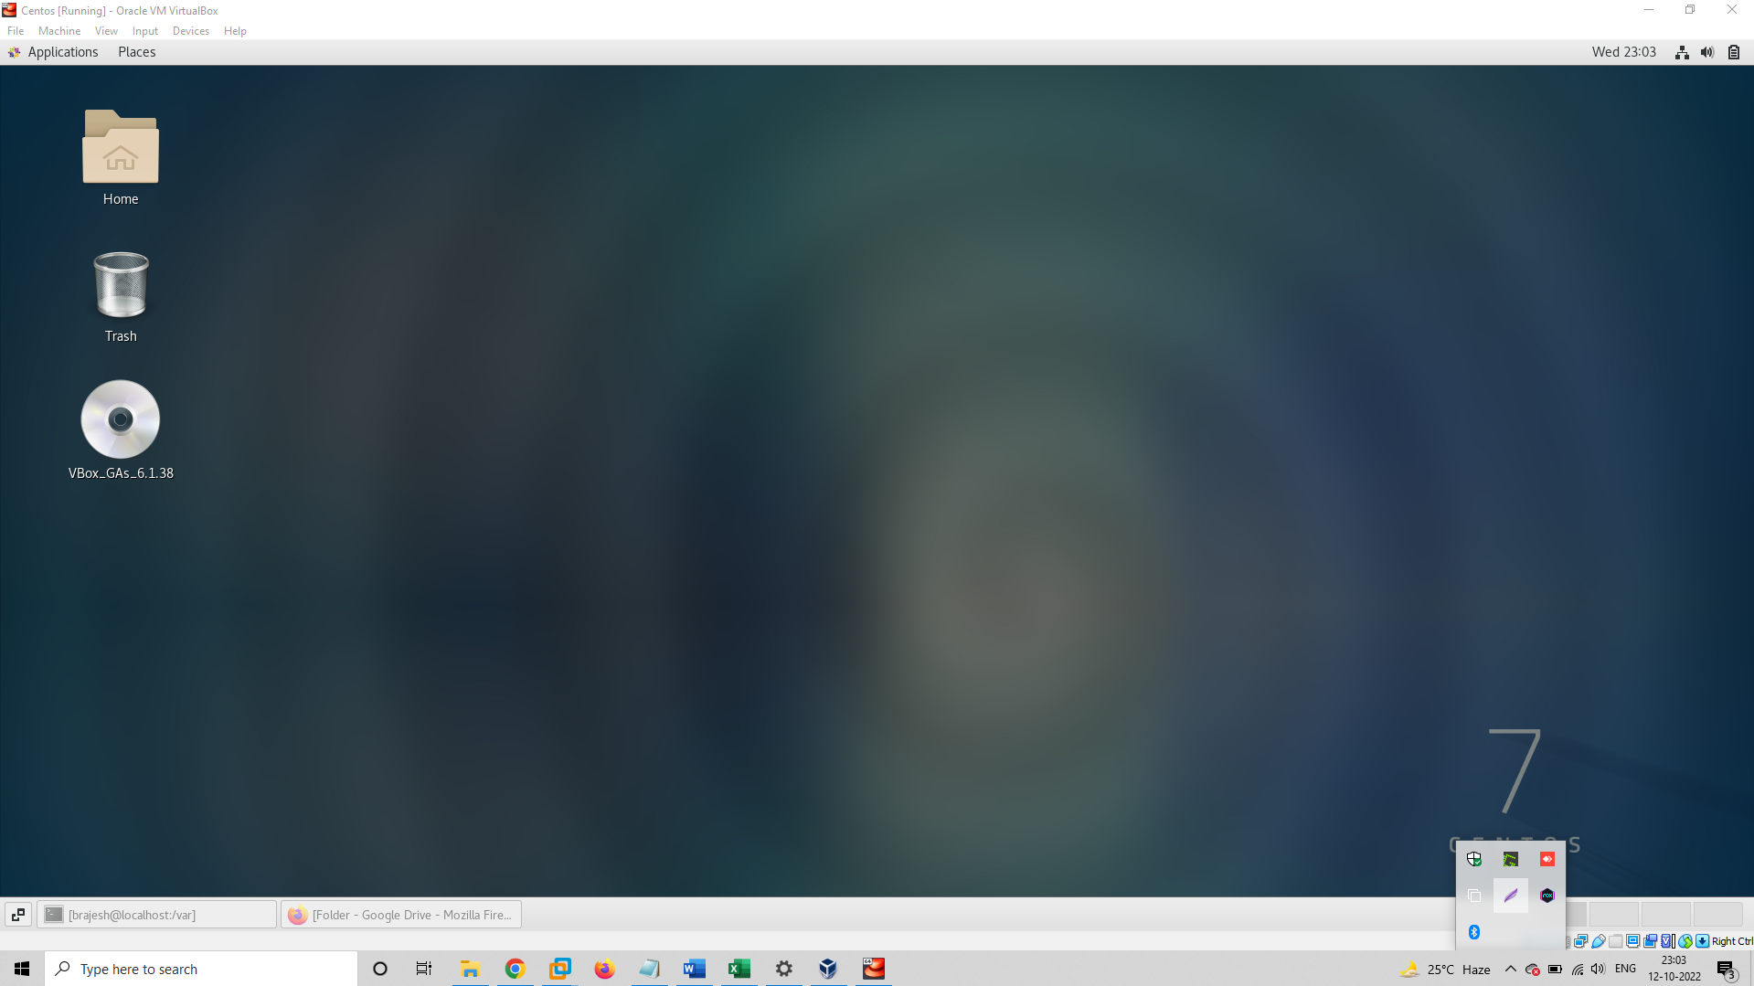

Assignment 2 :- Please update you CentOS machine

