|  |  |
| --- | --- |
| C:\Users\pc\AppData\Local\Microsoft\Windows\INetCache\Content.MSO\77F261F0.tmp | **< BSGB47 Banking System  >**    **Technical Design Document** |
| |  |  |  |  | | --- | --- | --- | --- | |  | **Prepared By / Last Updated By** | **Reviewed By** | **Approved By** | | **Name** | Bhaaavana Mishra(909226),    Satabdi Tanaya(908991),    Braj Singh(909334). | Lata (t-lata)  Bambhwani |  | | **Role** | Team Leader |  |  | | **Signature** |  |  |  | | **Date** | 05-05-2021 |  |  | |

**Table of Contents**

1. **Introduction**

**2.0** Purpose of this document

**3.0**  Project Overview

**4.0 Solution Summary**

**5.0**  Scope

**6.0** Assumptions

**7.0**  Dependencies

**8.0 Schematic Diagram**

**9.0 System Diagram**

**10.0** Purposed Diagram

**11.0** Component Inventory

Model Classes

**12.0 Database Design**

**13.0** Data Model

**14.0** Tables

**15.0 Terms and Conditions**

**16.0 Change Log**

1. Introduction

2.0 Purpose of this document

The purpose of this document is to document the technical design, component details and Database design. This will also capture the scope, assumptions, risk and dependencies of this project.

3.0 Project overview

        BSGB47 Banking Solutions has been a prosperous Bank with a good customer base. Currently they are losing their customers, because they do not have an online identity.  They are losing their customers because of lockdown, restricted opening hours and increasing competition from other banks. The volume of complaints has increased and resulted in chaos. This has resulted in a lot of duplication of efforts and at times wastage of efforts also. They also have customers who are not accustomed to smart browsing.  Hence BSGB47Banking Solutions has hired POD 007 of Cohort 004 to give them a solution.

After assessing the complete situation we have come up with the following recommendations.

a)Taking into consideration their budget, We will develop a mobile first approach website for them,We are going for a mobile application because of security,time and budget constraints.

b)A complete Banking solution will be available online which can be accessed through user id and password provided by the bank,Bank will provide two password login password and Transaction password.

c) Customers can make Online Transactions via neft and imps(neft for within the bank transactions and imps for within and other bank transactions)

d)Customers can view their reports,We will provide reports and it will for offline download in the format of xls and pdf.The Five Reports are (Ministatement,Monthly Statement,Period Statement,Balance Enquiry,Subscription Enquiry)

e)For safety we have included 2step authentication for profile viewing and 3 step for transactions,Users can log in using user id and login password and after otp authentication they can view their profile and statement but for making any kind of Transactions they need to enter transaction password also.

f)Users will have different types of limits and and benefits depending on the type of account they hold(salay,saving,current)

g) We are also providing some other useful tools like (cheque issue,atm block,schedule transactions).

 We intend to use agile methodology. We will divide the work in 2 sprints.  We will try to gather all data in a detailed one time visit to All4Safe7 Banking Solutions. Further communication will be done through digital means. A continuous dialogue with BSGB47 will ensure that BSGB47's expectations are being met. Thus we will help to provide BSGB47 with a workable and instant solution to their newly emerged problem.

1. Solution Summary

5.0 Scope

BSGB47 Banking System has the ability to provide user their user id and password and make easier to view the information related to the account and the record get updated every time when any action is done in account.

1.User can make online NEFT transactions (even outside bank)

2.User can make online IMPS transactions (even outside bank)

      3. User can generate ATM PIN.

4.User can give a request to block ATM.

5. User can change password (login password)

6 User can give request for a new cheque book

7. User can add, delete and update a beneficiary.

6.0 Assumptions

The application is designed for the users’ who already have accounts so that they can avail for the account login id and password.

1. Dependencies

* MS SQL Server 2018 needed for the database operations.
* Visual Studio 2019 software used to build and run the application

1. Schematic Diagram

A schematic, or schematic diagram, is a representation of the elements of a [system](https://en.wikipedia.org/wiki/System) using abstract, graphic [symbols](https://en.wikipedia.org/wiki/Symbol) rather than realistic pictures. It gives an overview of overall system**.**

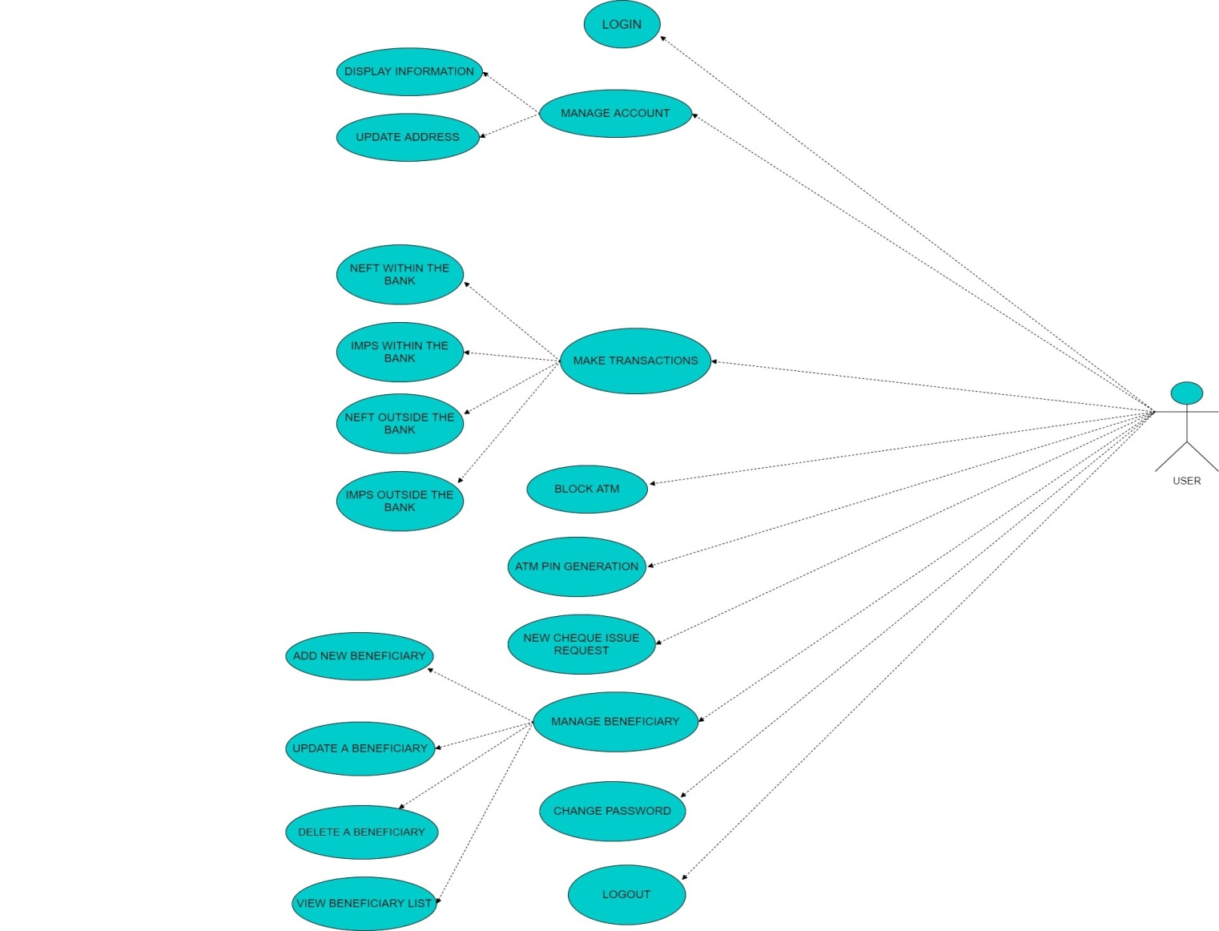

9.0 System Design

10.0 Proposed design

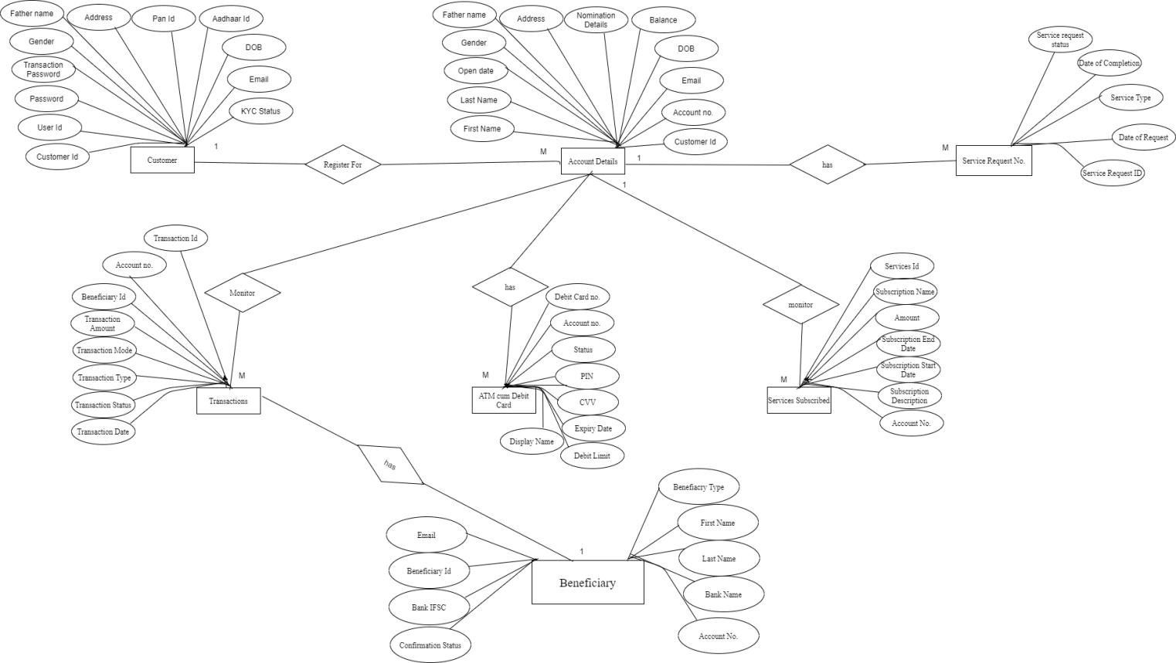

11.0 Component inventory

  Model classes

1. AdminHome.cs
2. RegisteredUserHome.cs
3. Home.cs
4. Cart.cs
5. payment.cs
6. profile.cs
7. orders.cs

12.0 Database Design

13.0 Data Model

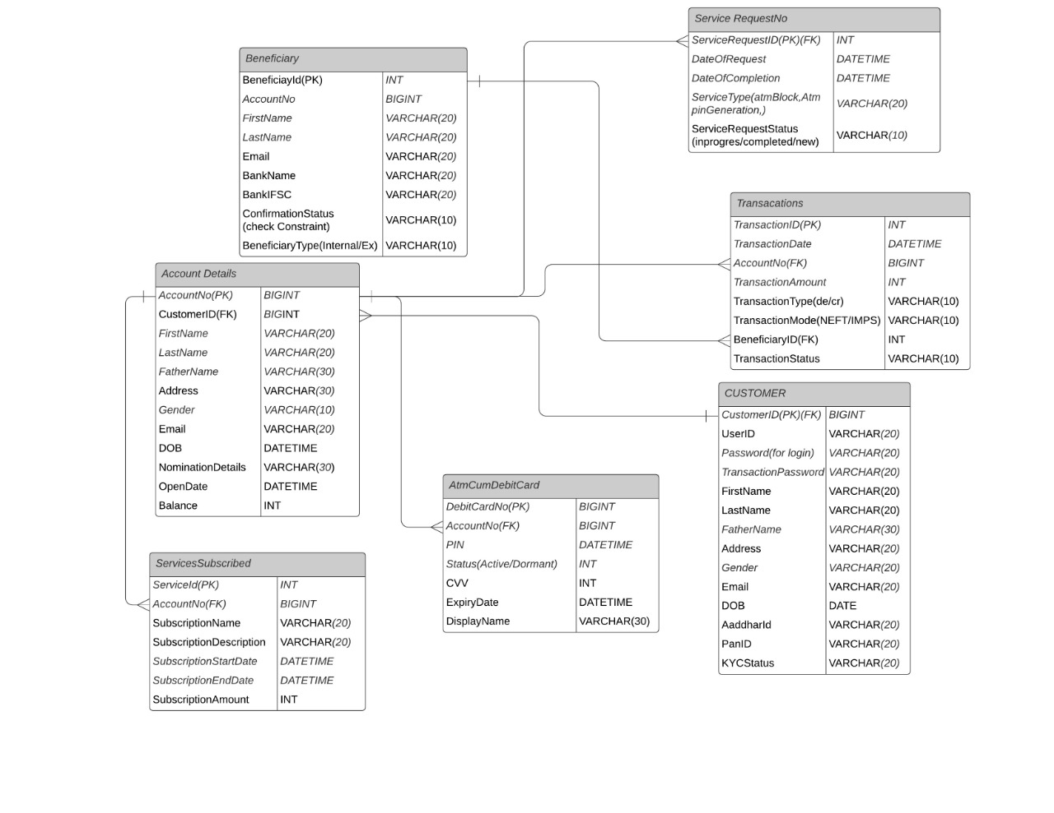

14.0 Tables Structure

Beneficiary

|  |  |  |  |  |
| --- | --- | --- | --- | --- |
| **Field Name** | **Field Type** | **Data Type** | **Mandatory** | **Possible Values** |
| **BeneficiaryId**  **(PK)** | Numeric | INT | Yes | Autogenerated |
| **AccountNo** | Numeric | BIGINT | Yes |  |
| **FirstName** | Text | varchar(20) | Yes |  |
| **Email** | Text | Varchar(20) | Yes |  |
| **BankName** | Text | Varchar(20) | Yes |  |
| **BankIFSC** | Text+  Numeric | Varchar(20) | Yes |  |
| **Confirmatio-n Status** | Text | Varchar(20) | Yes |  |
| **Beneficiary**  **Type** | Text | Varchar(20) | Yes |  |

Account Details

|  |  |  |  |  |
| --- | --- | --- | --- | --- |
| **Field Name** | **Field Type** | **Data Type** | **Mandatory** | **Possible Values** |
| **AccountNo** | Numeric | Bigint | Yes | Autogenerated |
| **CustomerId** | Numerict | Bigint | Yes | PreLoaded |
| **Fisrt Name** | Text | Varchar(20) | Yes |  |
| **Last Name** | Text | Varchar(20) | Yes |  |
| **Father Name** | Text | Varchar(30) | Yes |  |
| **Address** | Text | Varchar(30) | Yes |  |
| **Gender** | Text | Varchar(10) | Yes |  |
| **Email** | Text | Varchar(20) | Yes |  |
| **DOB** | Numeric | Date | Yes |  |
| **Nomination Details** | Text | Varchar(30) |  |  |
| **Open Date** | Numeric | Date | Yes |  |
| **Balance** | Numeric | Int |  | PreLoaded |

Services Subscribed

|  |  |  |  |  |
| --- | --- | --- | --- | --- |
| **Field Name** | **Field Type** | **Data Type** | **Mandatory** | **Possible Values** |
| **ServiceId** | Numeric | int | Yes | Autogenerated |
| **Account No** | Numeric | bigint | Yes | Preloaded |
| **Subscription Name** | Text | Varchar(20) | yes |  |
| **Subscription Description** | Text | Varchar(20) |  |  |
| **Subscription Start Date** | Date | Date time |  |  |
| **Subscription End Date** | Date | Date time |  |  |
| **Subscription Amount** | Numeric | int |  |  |

Atm Cum Debit Card

|  |  |  |  |  |
| --- | --- | --- | --- | --- |
| **Field Name** | **Field Type** | **Data Type** | **Mandatory** | **Possible Values** |
| **Debit Card No** | Numeric | Bigint | Yes | Auto-Generated |
| **Account No** | Numeric | Bignit | Yes | Pre-loaded |
| **PIN** | Numeric | Date Time | Yes | Pre-loaded |
| **Status** | Text | int | Yes | Pre-loaded |
| **CVV** | Numeric | int | Yes | Pre-loaded |
| **Expiry Date** | Date | Date Time | Yes | Pre-loaded |
| **Display Name** | Text | Varchar(30) | Yes | Pre-loaded |

Service Request No

|  |  |  |  |  |
| --- | --- | --- | --- | --- |
| **Field Name** | **Field Type** | **Data Type** | **Mandatory** | **Possible Values** |
| **Service Request Id** | Numeric | Int | Yes | Autogenerated |
| **Date of Request** | Numeric | Date time | Yes | Preloaded |
| **Date of Completion** | Numeric | Date time | Yes | Preloaded |
| **Service Type(ATM block,Atm pin generation)** | Numeric | Varchar(20) | Yes |  |
| **Service request status(in progress,completed,new)** | Text | Varchar(20) | Yes |  |

Transactions

|  |  |  |  |  |
| --- | --- | --- | --- | --- |
| **Field Name** | **Field Type** | **Data Type** | **Mandatory** | **Possible Values** |
| **Transaction Id** | Numeric | Int | Yes | Autogenerated |
| **Transaction Date** | Numeric | Int | Yes | Autogenerated |
| **Account no** | Numeric | Bigint | Yes | PreLoaded |
| **Transaction Amount** | Numeric | Int | Yes |  |
| **Transaction type** | Text | Varchar(10) | yes |  |
| **Transaction Mode** | Text | Varchar(10) | yes |  |
| **BeneficiaryID** | Numeric | Int | yes | Preloaded |
| **Transaction status** | Text | Varchar(10) | yes |  |

Customer

|  |  |  |  |  |
| --- | --- | --- | --- | --- |
| **Field Name** | **Field Type** | **Data Type** | **Mandatory** | **Possible Values** |
| **CutomerId** | Numeric | Bigint | Yes | Autogenerated |
| **UserId** | Text | Varchar(20) | Yes |  |
| **Password** | Text | Varchar(20) | Yes |  |
| **Transaction Password** | Text | Varchar(20) | Yes |  |
| **First Name** | Text | Varchar(20) | Yes |  |
| **Last Name** | Text | Varchar(20) | Yes |  |
| **Father’s Name** | Text | Varchar(30) | Yes |  |
| **Address** | Text | Varchar(20) | Yes |  |
| **Gender** | Text | Varchar(20) | Yes |  |
| **Email** | Text | Varchar(20) | Yes |  |
| **Dob** | Date | Date | Yes |  |
| **Aadhaar ld** | Text | Varchar(12) | Yes |  |
| **Pan Id** | Text | Varchar(10) | Yes |  |
| **KycStatus** | Text | Varchar(20) | Yes |  |

15.0 Terms & Conditions

***Disclaimer: Please do not circulate or distribute this document outside of Cognizant Network, We have a Zero Tolerance Policy. Kindly adhere to 100% Compliance at all times.***

16.0 Change Log

*Please note that this table needs to be maintained even if a Configuration Management tool is used.*

|  |  |  |  |  |
| --- | --- | --- | --- | --- |
| **Version Number** | **Changes made** | | | |
| V<n.n> | *<If the change details are not explicitly documented in the table below, reference should be provided here>* | | | |
| Page no | Changed by | Effective date | Changes effected |
|  |  |  |  |
|  |  |  |  |
|  |  |  |  |
|  |  |  |  |