

smart traffic light

With IR and Bluetooth module



Project Report

Submitted by

1. Braj Kishor Singh
2. Anusha Guchait
3. Judhajeet Biswas

**COMPONENTS**

1. Arduino UNO
2. HC-05 Bluetooth Module
3. L.E.D.(4 Green,4 Red)
4. IR Sensors (4)
5. Breadboard
6. Jumpwires

**ABSTRACT and FUNCTION**

It is a smart traffic light system with 4IR sensors and a Bluetooth module.

I.R Sensors are used to sense traffic jam and the Bluetooth Module is used to share data and information with android device.

On a usual case one of Lateral Roads (left-right or up down) are opened for 8 seconds for the movement of traffic then closed for 10 seconds. Ex if left-right road is opened and up down is closed at t=0 seconds, then left-right will be opened for 8seconds i.e. It will be open till t=8Seconds and closed for next two seconds i.e. for(t>8 and t<=10) left right road will be closed at same time up-down road will be closed for 10 seconds i.e. for t=0 to t=10seconds up-down road will be closed, then up-down road is opened and left-right is closed at t=0 seconds, then up-down will be opened for 8seconds i.e. It will be open till t=8Seconds and closed for next two seconds i.e. for(t>8 and t<=10) up-down road will be closed at same time left-right road will be closed for 10 seconds i.e. for t=0 to t=10seconds left-right road will be closed.

This will continue if the traffic on closed road at that instant does not exceed the threshold level, if it happens that the traffic at the closed road exceeds the threshold level then it open the closed road and close the opened road above mentioned process. ex. if the left-right road is closed and up-down road is open then if traffic exceed the threshold level in left-right road ,it will override the normal process and open left-right road and close up-down road, in essence terminating the running cycle and restarting the favorable cycle, and then continue with the usual process. A mobile android device can also be used for the same purpose of terminating and initiating a favorable sequence.

**USE OF IR SENSOR**

4 IR sensor are used in this project each along the threshold line adjacent to the corresponding road to sense the presence of vehicle. Program is written assuming that a moving vehicle takes less than 3 seconds to cross the threshold line, If any vehicle takes more than 3seconds then it assumed to be standing on the threshold line indicating traffic jam on the closed road thereafter it open the road the closes the previously opened road.

**USE OF BLUETOOTH MODULE**

Bluetooth module HC-05 is used to send and receive data through an android app which is made through MIT APP INVENTORY. It enables manual override of the traffic lights control system.

LAYOUT

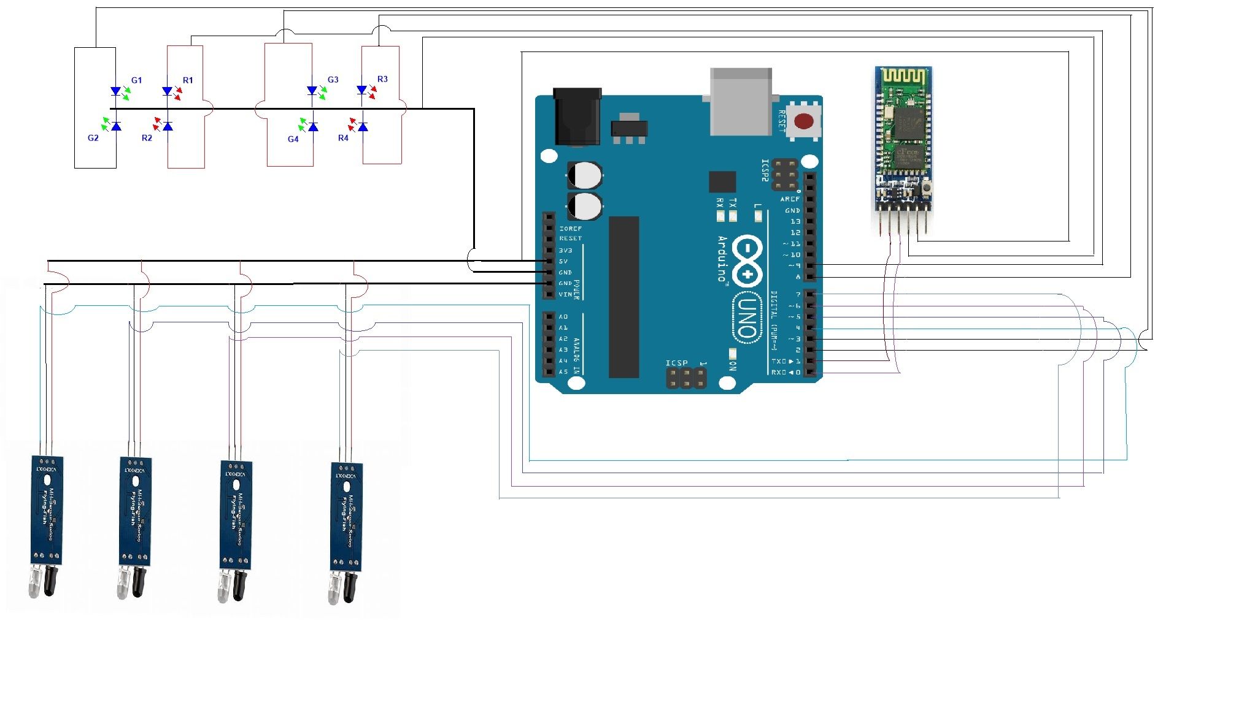

**CODE**

#define c1 3

#define c2 2

#define c3 8

#define c4 9

#define ir1 4

#define ir2 5

#define ir3 6

#define ir4 7

int i,t=1,a,b,c,d,e,t1=0,t2=0,t3=0,t4=0,lr=1,ud=1;

void setup() {

// put your setup code here, to run once:

pinMode(c1,OUTPUT);

pinMode(c2,OUTPUT);

pinMode(c3,OUTPUT);

pinMode(c4,OUTPUT);

pinMode(ir1,INPUT);

pinMode(ir2,INPUT);

pinMode(ir3,INPUT);

pinMode(ir4,INPUT);

Serial.begin(9600);

}

void loop() {

// put your main code here, to run repeatedly:

a=digitalRead(ir1);

b=digitalRead(ir2);

c=digitalRead(ir3);

d=digitalRead(ir4);

if(Serial.available() >0)

{

char data;

data=Serial.read();

switch(data)

{

case 'u' :

digitalWrite(c1,LOW);

digitalWrite(c4,HIGH);

delay(2000);

digitalWrite(c2,HIGH);

digitalWrite(c3,LOW);

delay(8000);

t=0;

break;

case 'd' :

digitalWrite(c1,LOW);

digitalWrite(c4,HIGH);

delay(2000);

digitalWrite(c2,HIGH);

digitalWrite(c3,LOW);

delay(8000);

t=0;

break;

case 'r' :

digitalWrite(c3,HIGH);

digitalWrite(c2,LOW);

delay(2000);

digitalWrite(c1,HIGH);

digitalWrite(c4,LOW);

delay(8000);

t=0;

break;

case 'l' :

digitalWrite(c3,HIGH);

digitalWrite(c2,LOW);

delay(2000);

digitalWrite(c1,HIGH);

digitalWrite(c4,LOW);

delay(8000);

t=0;

break;

}

}

else{

if(a==0)

t1++;

else

t1=0;

if(b==0)

t2++;

else

t2=0;

if(c==0)

t3++;

else

t3=0;

if(d==0)

t4++;

else

t4=0;

if(t1>6 || t2>6)

{

lr=1;

}

else

{

lr=0;

}

if(t3>6 || t4>6)

{

ud=1;

}

else

{

ud=0;

}

//main work starts here

// ud=0 && lr=0 means no jam ,traffic light works according to its timer of 2 seconds

if(lr==0 && ud==0){

if(t<21) //blinking time set as 10 seconds 2seconds red 8 sec green

{

digitalWrite(c3,HIGH);

digitalWrite(c2,LOW);

if(t>4)

{

digitalWrite(c1,HIGH);

digitalWrite(c4,LOW);

}

}

else

{

digitalWrite(c1,LOW);

digitalWrite(c4,HIGH);

if(t>24)

{

digitalWrite(c2,HIGH);

digitalWrite(c3,LOW);

}

if(t==40)

{

t=0;

}

}

t++;

}

//lr==1 means traffic in left right road has exceed threshold value

else if(lr==1)

{

digitalWrite(c3,HIGH);

digitalWrite(c2,LOW);

delay(2000);

digitalWrite(c1,HIGH);

digitalWrite(c4,LOW);

delay(8000);

t=0;

}

//ud==1 means traffic in up down road has exceed threshold value

else if(ud==1){

digitalWrite(c1,LOW);

digitalWrite(c4,HIGH);

delay(2000);

digitalWrite(c2,HIGH);

digitalWrite(c3,LOW);

delay(8000);

t=0;

}

delay(500);

}

if(c1==HIGH)

{

Serial.println(UP-DOWN);

}

else

{

Serial.println(LEFT-RIGHT);

}

}