Reproduced analysis of FARS data

Scott Braley

### Results

Percentages of drivers testing positive by drug type, sex and year group

|  |  |  |  |  |  |  |
| --- | --- | --- | --- | --- | --- | --- |
| Drug type | F 1999-2002 | F 2003-2006 | F 2007-2010 | M 1999-2002 | M 2003-2006 | M 2007-2010 |
| Alcohol | 26.4 | 24.3 | 27.1 | 43.2 | 42.9 | 43.3 |
| Cannabinoids | 2.8 | 5.8 | 7.4 | 6.0 | 10.7 | 12.2 |
| Depressants | 3.5 | 3.9 | 4.9 | 2.0 | 2.5 | 3.2 |
| Narcotics | 4.3 | 5.0 | 7.3 | 2.2 | 3.4 | 4.0 |
| Other | 5.8 | 6.8 | 7.5 | 4.4 | 4.6 | 4.3 |
| Stimulants | 7.3 | 9.3 | 8.9 | 10.7 | 12.3 | 9.5 |
|  |  |  |  |  |  |  |

Figure 1: Prevalence of nonalcohol drugs in fatally injured drivers by year and age group 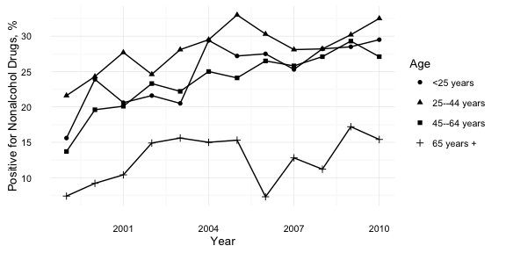

Figure 2: Prevalence of nonalcohol drugs in fatally injured drivers by year and drug type 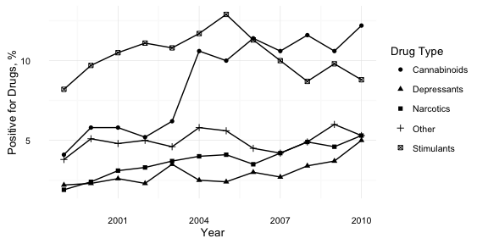

Figure 3: Prevalence of cannabinoid drugs in fatally injured drivers by year and age group 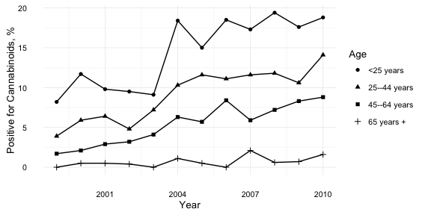

Prevalence of drugs in fally injured drivers for 1999 and 2010 by drug type

|  |  |  |
| --- | --- | --- |
| Drug type | 1999 | 2010 |
| Alcohol | 37.4% (35.3%, 39.6%) | 38.6% (36.2%, 41%) |
| Narcotics | 1.7% (1.1%, 2.2%) | 5% (3.9%, 6.1%) |
| Depressants | 1.9% (1.3%, 2.5%) | 4.8% (3.7%, 5.8%) |
| Stimulants | 7.3% (6.2%, 8.5%) | 8.3% (7%, 9.7%) |
| Cannabinoids | 3.7% (2.9%, 4.5%) | 11.5% (10%, 13.1%) |
| Other | 3.4% (2.6%, 4.2%) | 5% (3.9%, 6.1%) |

Statistics for testing for trend in prevalence of drugs over study years by drug type using Cochran-Armitage trend test

|  |  |  |
| --- | --- | --- |
| drug | Z | p.value |
| Alcohol | 1.2 | 0.228 |
| Nonalcohol | 11.5 | 0.000 |
| Narcotics | 6.8 | 0.000 |
| Depressants | 4.8 | 0.000 |
| Stimulants | 0.4 | 0.720 |
| Cannabinoids | 13.7 | 0.000 |
| Other | 1.5 | 0.146 |
|  |  |  |

Statistics for testing for trend in prevalence of drugs over study years by drug type using Wald test of logistic regression coefficient for year

|  |  |  |
| --- | --- | --- |
| drug | Z | p.value |
| Alcohol | 1.2 | 0.228 |
| Nonalcohol | 11.5 | 0.000 |
| Narcotics | 6.8 | 0.000 |
| Depressants | 4.8 | 0.000 |
| Stimulants | -0.4 | 0.720 |
| Cannabinoids | 13.6 | 0.000 |
| Other | 1.5 | 0.146 |
|  |  |  |