Depth buffer
pas bij volledige rendering buffers swappen

- shaders = programmas die bepalen hoe graphics gerendert worden. → gpu
  - Opengl shading language
  - een shader doet dus iets extra, geeft door
- fragment = mogelijke pixel, nog geen echte
- vertex buffer object= buffer voor data naar gpu te zetten, alle data die nodig is om object te renderen, zoals vertex posities, normale of textuurcoordinaten
  - hierbij zijn andere opties mogelijk
- vertex array object = platte array die alle specificaties van een object bijhoudt.
  - Hoe moet opengl de data implementeren en linken aan vertex shader
- vao slaagt alle calls op die gedaan werden
  - ook de vbo die ervoor werd “gebind”

opengl tutorial
- Core profile vs immediate mode
  - immediate = fixed fun ction pipeline
  - core profile = without deprecated code
  - using extensions in openGL, always query first before trying to use
    - not every piece of hardware supports everything
  - in 3.3 this shouldn’t be an issue
  - state machine = opengl, a collection of varialbes that define how opengl should be operating in that moment
    - manipulation of state is done trough setting options, manipulating buffers and rendering the context
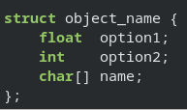
  - opengl abstraction → objects in opengl
    - boejct = a collection of options that represent as ubset of the opengl state.
    - Example:
    - in opengl visualise as one structit would like this
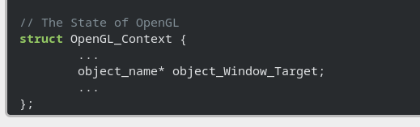
    - basic object representation in opengl
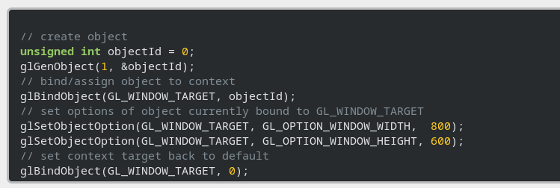
    - create an object and store a reference to it by using an id
      - the real data is stored somewhere else
    - object is binded to a location in the context, GL WINDOW TARGET
    - then you unbind
    - objects are set and stored in the object referenced by the object ID, and these are restored as soon as you bind back to the gl window target.

